As a Professional Liberty user, you now have the ability to see the Goal % and Actual % in the Account Holdings – this is not viewable by your representatives or account owners.
When “View by Model” is selected on the Account Holdings tab, the Goal % and Actual % is displayed in the Holdings table as shown below:
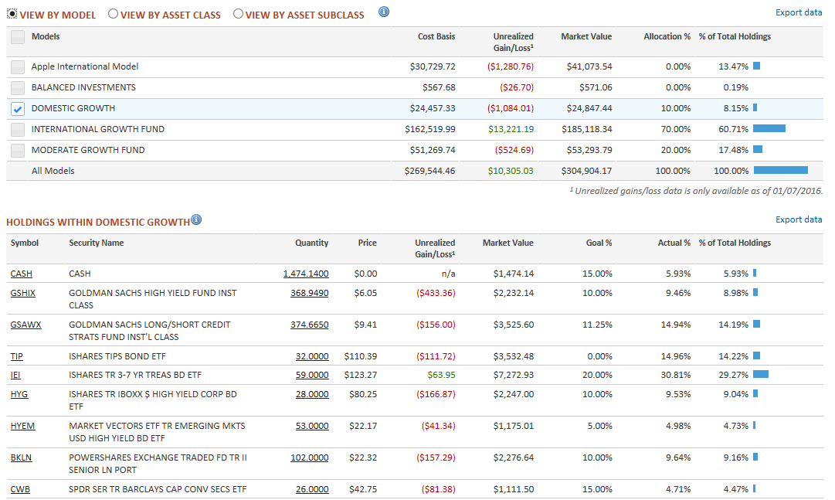

Selecting a model in the above table enables the columns to appear in the lower table. Goal % is always as of current date, even when viewing for historical or future dates
Let your relationship manager know if you have questions.

