August 2015

**Liberty Contacts**   
User Guide

Table of Contents

Quick Start Guide 3

General Usage Notes 3

What is Included? 4

Navigation 5

Searching for a Record 6

Viewing a Record 6

Quick Link Navigation 7

Creating a New Contact Record 7

Archiving a Contact Record 8

Restoring an Archived Contact 9

Contact Information 10

Communication History & Notes 12

Proposals 13

Accounts 16

Using / Creating a Contact While Initiating a Proposal or Account 18

Ownership and Visibility of Records 20

Helpful Hints 20

Tablet Navigation 20

# Quick Start Guide

For those familiar with using other areas of the Liberty application, the following Quick Start Guide provides the basic information you need to get up and running with the Contacts functionality within Liberty. Please refer to individual sections for more information.

* **Navigate** to the *Contact* area by selecting the *Prospecting Tools* Tab. This will place you on the *Contacts* search landing page.
* Enter a few letters of the contact’s name or click **Search** without entering a name to generate a full list of contacts.
* Clicking on the radio button next to a contact will display a summary of the contact information to the right of the screen. Click on the contact name or the **Edit Contact** button to see the detailed information for the individual.
* Click the **Create** button contacts search page to add a new record.
* Enter contact information and click either **Continue** or **Save**. All fields are optional with the exception of the contact’s name, which is required.
* Click the **Create Proposal** button while on the *Proposals* screen to initiate a proposal directly from the contact record.
* Clicking the **Create Account** button while on the *Accounts* screen will seamlessly open the new account template pre-populated with the individual’s information.

# General Usage Notes

* Liberty Contacts has the same robust user authorizations inherent throughout Liberty and TCAdvisor. You can tailor user access to authorize only those functions deemed appropriate.
* As with most web-based applications, you should use the navigation options provided within Liberty rather than your browser’s back button. In many cases the browser back button will return you to the prior screen, however it may not refresh entirely.
* Always tab off of or click out of a field after entering data. This tells the Liberty application that you are done entering data in the field and allows it to validate the entry.
* **Save** and **Continue** actions will commit any changes to the database. The system will automatically save changes when navigating between sub-sections of the contact record.
* The system will conduct a good order review each time the user navigates to a new page or presses the **Save** or **Continue** buttons.
* Error and Informational messages are generally displayed at the top of the screen and contain helpful information regarding errors or actions about to be taken. For ease of identification any erring fields will be noted in red.
* **Cancel** will discard any changes and either close the pop-up window or return you to the prior screen.

# What is Included?

* One stop contact management system employing Liberty’s easy and intuitive user interface.
* Simple and secure method for storing prospect and client contact information.
* Integration & Accuracy - Seamless integration to the proposal generation and account opening processes.
* Workflow Efficiency - Ability to track appointments, reminders and document contact history notes.
* Ownership and control of the contact information. The RIA/Representative “owns” all the information, with full authority to create, edit or delete records.
* The data is fully exportable. The RIA/Representative can transfer contacts to another CRM, create ad-hoc reports, conduct data mining, etc.
* The initial implementation lays the foundation for future functionality including the ability to import data from other CRM systems, initiate segmented marketing campaigns based on prospecting activities & client demographics, and predefined workflow processes/alerts all coupled with automated client notifications.

# Navigation

The tabs at the top of the screen define major areas of functionality within Liberty. The *Contact* search landing page is the default view when entering the *Prospecting Tools* tab.

 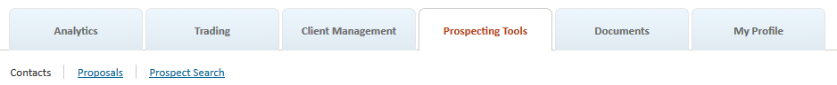

When first entering the *Contacts* screen no contact records will be displayed. This is by design. Conduct a search or apply a filter to refine the listing on the lower portion of the page.

Sub-navigation is provided in the left-most panel.

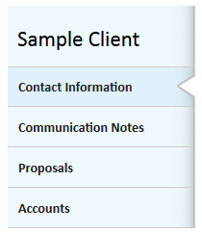

You can always return to the *Contacts* search page by clicking on the *Prospecting Tools* top level navigation tab or the **Return to Search** button located in the Action Dock.



The *Prospecting Tools* tab is resource controlled.  Only those RIAs/Reps with the appropriate permissions will be able to access, edit & create contact records. This means the appearance and available options on the screens may vary depending on the user’s assigned role.

# Searching for a Record

Search for an individual by entering one or more letters of the client’s name or simply hit the **Search** button to display all records.

* The search is conducted using “contains” logic and will return matches where the search string is contained anywhere in the person’s first or last name.
* Check the **Include Archived** box to include archived contacts in the search results.

 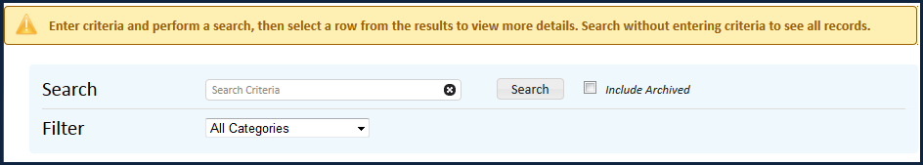

* Search results are displayed on the lower portion of the page.
* Standard sort functionality applies to each column. The default sort is alphabetical based on name.

# Viewing a Record

* Marking the radio button next to an entry will provide a summarized view of the primary contact information in the right-most display.
* To view the detailed contact information simply click on the individual’s name or press the **Edit Contact** button in the summary view.

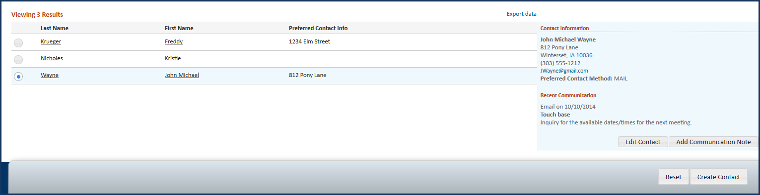

* Click on the **Return to Search** button in the Action Dock to exit the contact record and return to the search results page. (Any search parameters or filters that were previously applied will be retained for the duration of the session – or until the reset button is pressed.)



# Quick Link Navigation

Select the desired sub-screen for a Contact to seamlessly navigate directly to that screen.

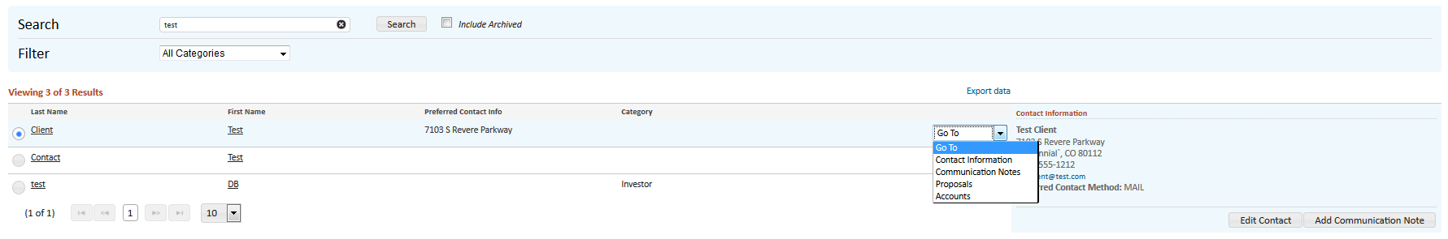

# Creating a New Contact Record

Click on the **Create** button in the Action Dock at any time to initiate a new contact record.

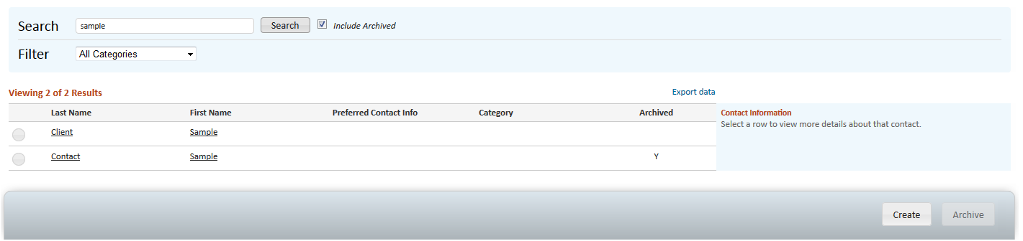

Once the name is entered the record can be saved. All other information is optional and can be populated as desired.

Page and field-level business rules have been applied to each section to ensure accuracy and completeness. As an example, if a phone number is entered then the corresponding phone type must be provided. For ease of identification, any offending fields will be highlighted in red.

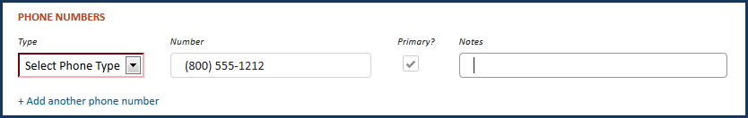

Remember to **Save** before returning to the *Contacts* search landing page.

Press the **Continue** button to page through the various sub-sections. The system will automatically save changes when navigating between sub-sections of the contact record.



Clicking on the **Cancel** button in the Action Dock will abort the new record without saving and return you to the search results page. The **Cancel** button has the added feature of exiting the contact record once it has been saved.

# Archiving a Contact Record

Click on the radio button next to the record you want to archive (delete) to enable the **Archive** button.

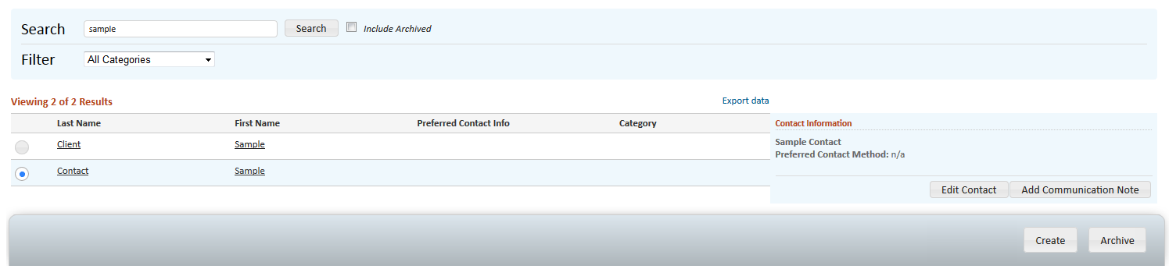

Pressing the **Archive** button will trigger a confirmation message. Chose **Yes** to proceed or **Cancel** to halt the process.

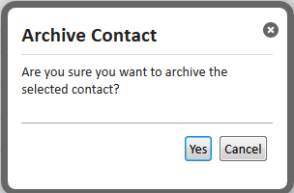

# Restoring an Archived Contact

Archived contact records are retained in the database. To restore an archived record you first need to mark the **Include Archived** box on the Contact Search screen.

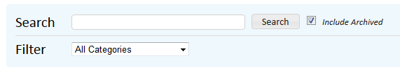

Archived records will appear in the search results table along with the archived flag for easy identification.

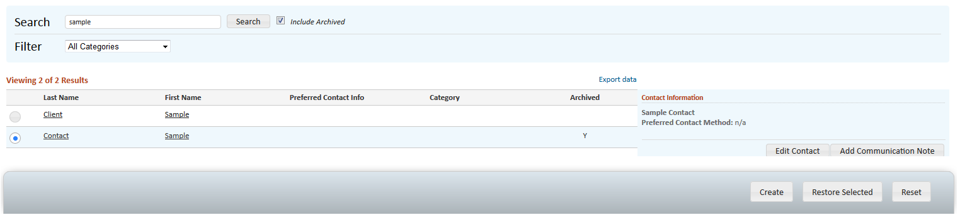

Mark the radio button for the contact record to be restored and press the **Restore Selected** button. The contact has now been restored.

# Contact Information

As the name implies, this is the location where the individual’s name, address, contact and personal identification information is stored.

Only the first and last names are required. All other information is optional and can be populated as desired.

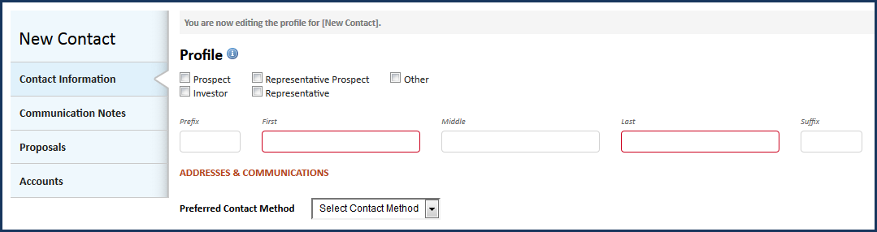

Each contact is systematically assigned a category based on the unique attributes and characteristics of the individual. Upon initial entry no category is assigned.

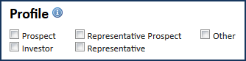

* **Prospect:** Initiating a proposal for the individual will result in the person being categorized as a "Prospect".
* **Investor:** Linking the contact record to a TCA account will result in the category being converting from "Prospect" to "Investor".
* **Representative Prospect:** Records created via import from the Rep Prospecting tool will initially be assigned a role of "Representative Prospect".
* **Representative:** The record is re-categorized from "Representative Prospect" to "Representative" when an investment advisory agreement is executed and a new representative record is created for the individual in Liberty or TCAdvisor II.

To ensure accurate reporting the system assigned role cannot be changed by the user. However additional roles can be added to (or removed from) a contact to facilitate your unique workflow and reporting needs.

Click the **+Add Another** link under the address, phone and email sections to add additional contact information. There is no limit.

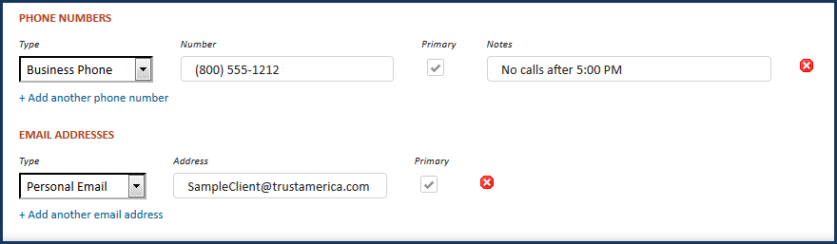

To remove a specific address, phone number or email address, simply click the  next to the record. (Warning: Once deleted the address, phone number or email address cannot be restored.)

For added security personal identification information (PII) is masked upon entry. Click into the field to reveal the full number.

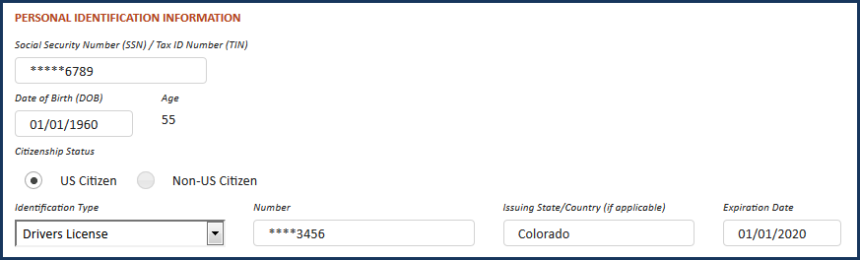

# Communication History & Notes

Arguably the most valuable aspect of any contact database is the ability to store notes about client interactions and have this information readily retrievable upon demand.

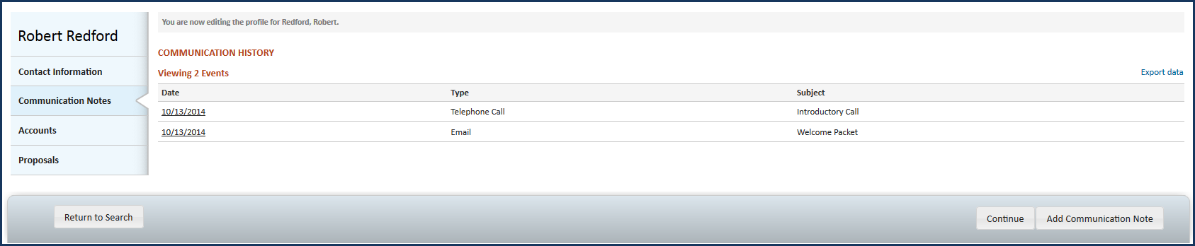

Click on a Communication History entry to see more information about the event or press the **Add Communication Note** button to enter a new event.

Communicates Notes are displayed chronologically in descending order, with the most recent notes appearing at the top of the list.

Adding, editing and deleting communication events can be accomplished through the intuitive Action Dock commands.

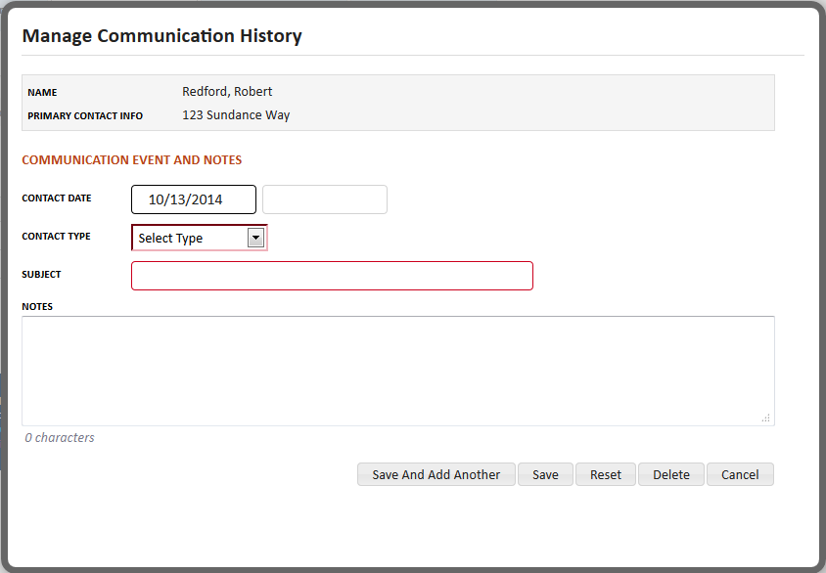

The window will automatically close upon saving the note.

# Proposals

The Proposals screen lists the proposals generated for a prospective client. The proposal information will refresh each time the screen is accessed.

The Proposal Name contains a hyperlink, which when evoked, provides quick navigation to the *Proposal Information* page.

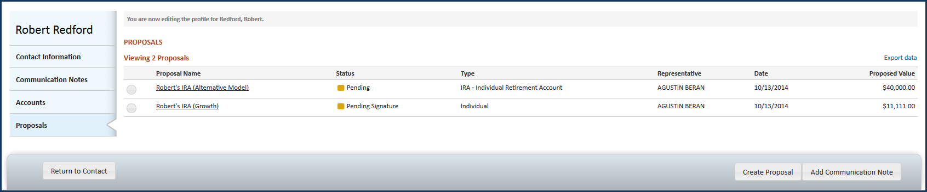

Clicking the **Create Proposal** button in the Action Dock provides an easy way to initiate a new proposal directly from a contact record. The client’s contact information will auto-populated into the new proposal template and the newly created proposal will be automatically included in the *Proposals* list.

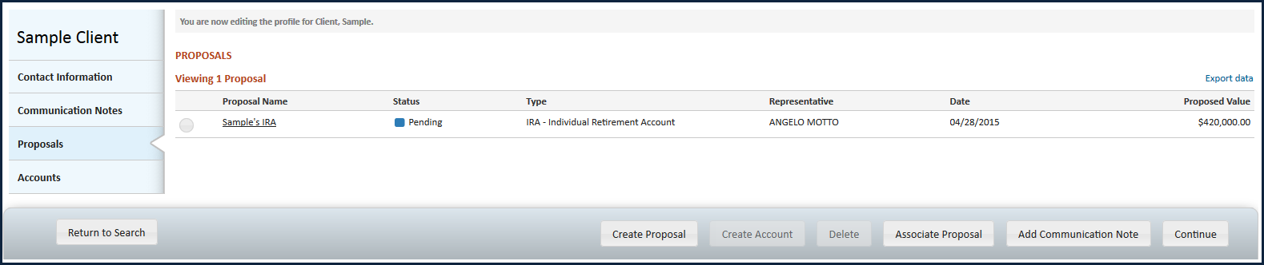

To “link” a previously created proposal to the Contact, simply click the **Associate Proposal** button in the Action Dock.



You will be presented with a *Proposal Search* dialog box, with the contact name populated in the search field and the search results displayed. You can apply additional search and filter criteria to fine-tune the results.

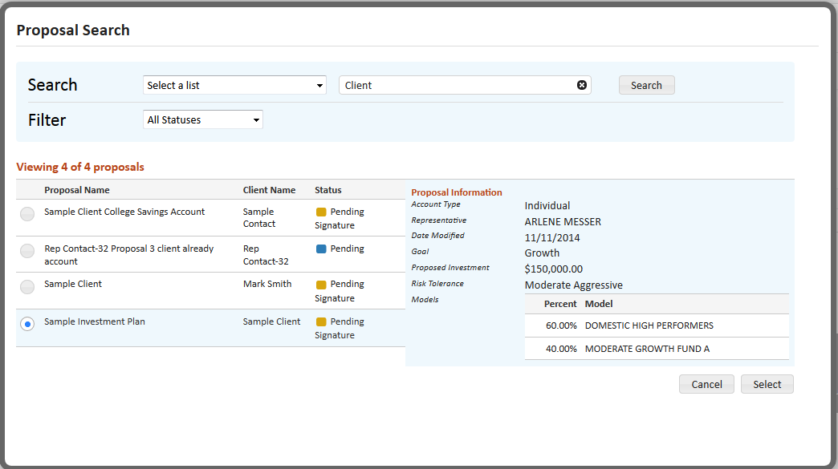

Select a proposal by marking the radio button next to each entry to display the proposal details. When you have located the desired proposal, click the **Select** button to finalize the “linking” process.

Pressing **Cancel** will close the window and return you to the Contact record without associating the proposal.

You can create a new account for any proposals with a “pending” status by selecting the proposal from the list and clicking the **Create Account** button.

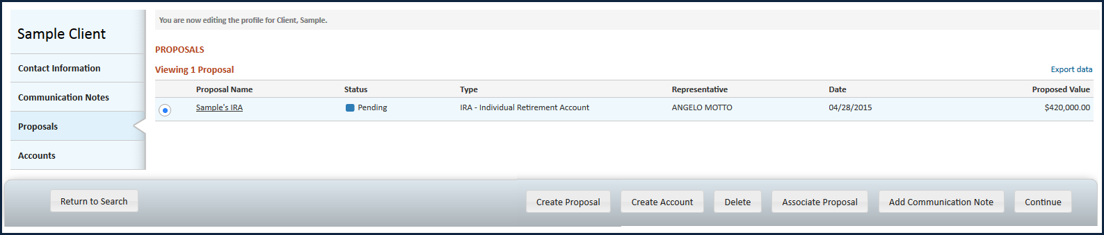

In situations where the proposal is “incomplete”, you have the option of providing the missing information or forgoing the account creation process.

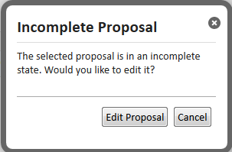

Clicking **Edit Proposal** will re-direct you to the *Proposals* screen, with the selected proposal displayed and ready for revision. In most situations entering the Model Allocation or Representative information will fulfill the good order requirements, after which the **Create Account** button on the lower portion of the page will be activated.

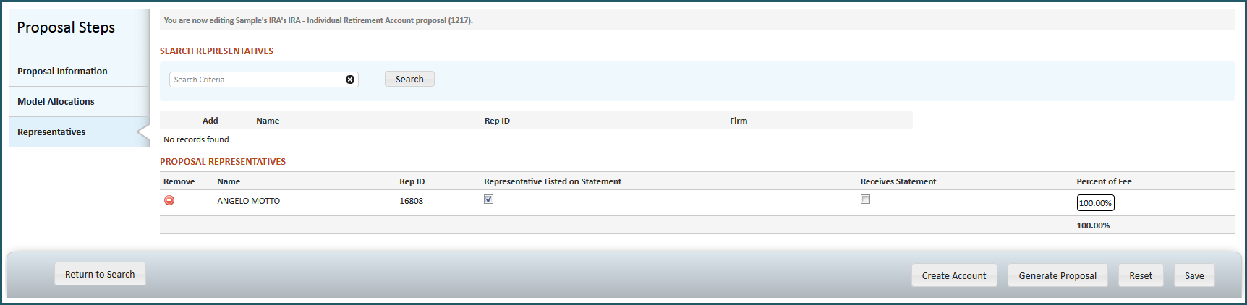

# Accounts

Link the contact record to existing TCA accounts or manually enter information for those accounts custodied outside of TCA to build a comprehensive view of the individual’s financial holdings.

* Press the **Associate Account** button in the Action Dock to enter account information.
* Once entered, you can view and/or edit the information by clicking the **Edit** button in the right-most column in the account list.
* TCA accounts contain a hyperlink associated with the account number which provides quick navigation to the *Account Overview* page.

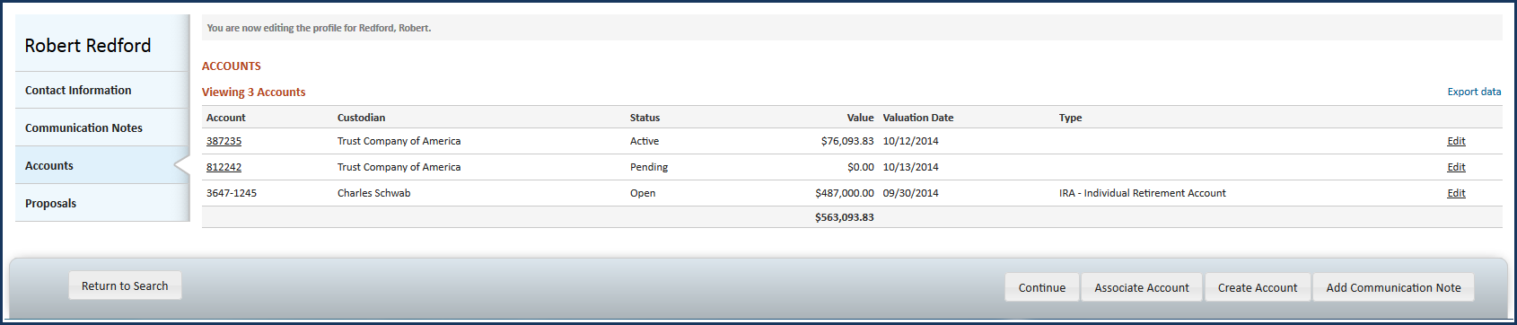

Accounts held at TCA

* When entering TCA account information the system will conduct a review to determine if 1) the account # is valid, 2) the Representative/RIA is authorized to view the account information.
* If the answer is YES to both, the TCA account will be “linked” to the contact record and all information will automatically refresh each time the contact record is accessed.
* To ensure the integrity of the data all fields will be locked for editing once the linkage occurs.

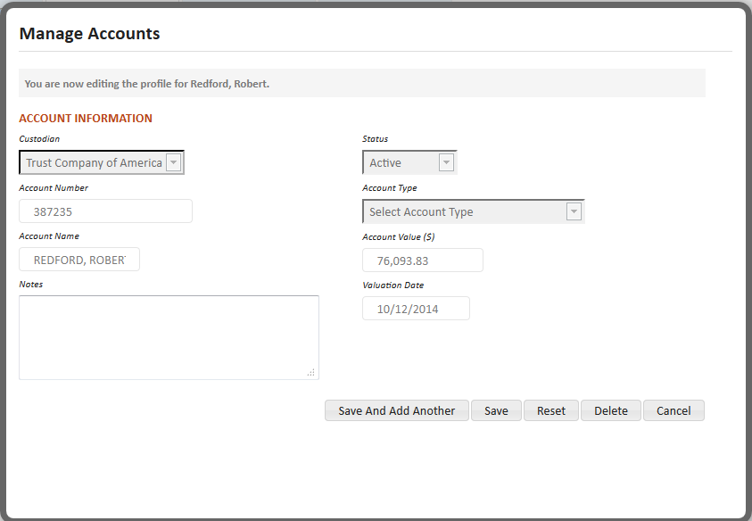

Accounts held outside TCA

* Entry of accounts custodied way from TCA is optional, with all fields enabled for entry/editing.
* Information on accounts held outside of TCA will not systematically update.

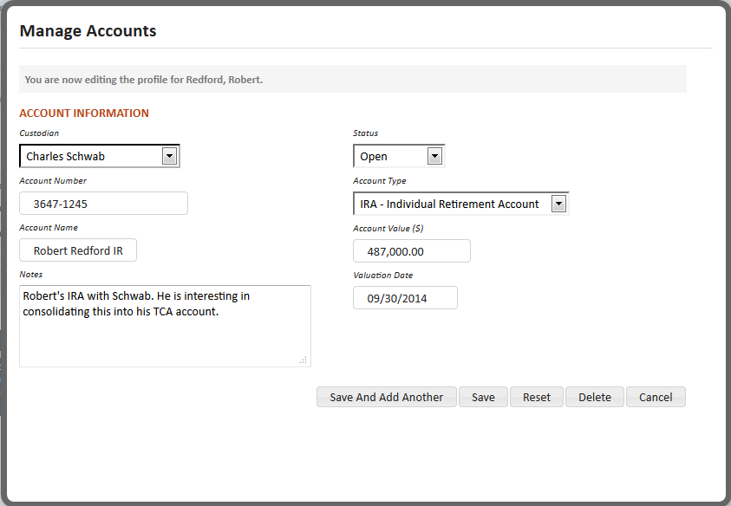

Seamless integration When Creating Accounts

Clicking the **Create Account** button in the Action Dock provides an easy way to initiate a new account directly from a contact record. The client’s name, address, personal identification and contact information will auto-populated into the new account template and application. In addition, the newly created account will be automatically added to the Accounts list.



# Using / Creating a Contact While Initiating a Proposal or Account

You can search for (and import) contact information directly into a proposal or account by entering a few characters of the client’s name in the Client Name field and pressing the **Find** button.

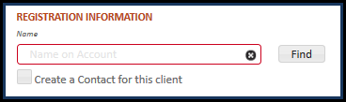

Note: Using the contact search feature to import a client’s contact information will result in any previously entered fields being overwritten. Therefore we recommending you use this feature as your first step when entering a new proposal or account.

In situations where a Contact record does not already exist for the client, mark the “**Create a Contact for this client**” check box and a new Contact record will be created as part of the proposal/account creation process.

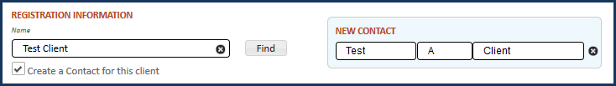

Modify the client’s name in the associated contact display. Upon saving the account the associated Contact information is displayed, allowing you to see more information by clicking the Contact name.

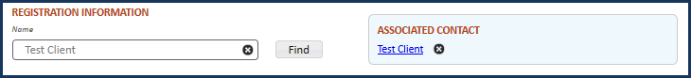

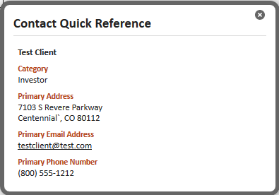

Informational messages at the top of the screen will inform you if the task was successful or if any errors were encountered.



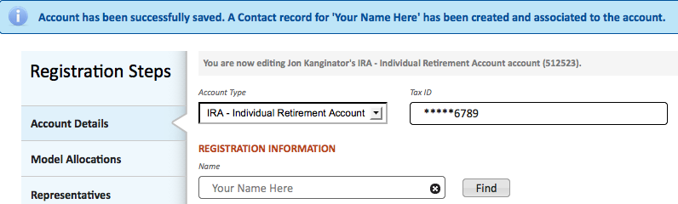

Using the **Find** or **Create a Contact** features will result in the proposal or account being automatically “associated” the Contact record. No additional action is required by you.

To prevent errors, the Client Name field will be disabled if you use the **Find** or **Create a Contact** feature.

Pressing the  next to the client’s name will clear the name, remove any associations to a Contact record, and re-enable the Client Name fields for entry.

Pressing the  next to the client’s name for the Associated Contact will clear just the associations to the Contact record. In this situation the registration information will remain unchanged.



You can re-associate the account to a Contact record by clicking the “None” field, which will cause the Contact Search dialog box. Enter a few characters of the client’s name in the Client Name field and press the **Find** button to locate the desired Contact.

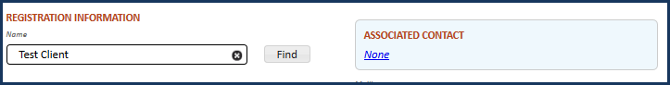

# Ownership and Visibility of Records

* A Representative will always maintain ownership and visibility to any records he/she creates.
* Visibility and ownership by others in the Representative’s hierarchy results from a triggering event.
  + Generally speaking, visibility will be restricted to just the record creator until the contact record is linked to a proposal or account using a RIA’s model.
  + Once the contact record is linked with a TCA proposal or account the RIA and Firm will gain visibility to that contact record.
* A RIA can initiate a proposal or open an account on behalf of a Representative. The Representative will see the contact record as soon as the RIA assigns the Representative to the proposal/account.

# Helpful Hints

* To provide the most benefit, and unless requested otherwise, users should be granted authority to view, edit and create contact records.
* Users with “create” authority will be able to modify/edit a newly created contact record for the duration of the login session. The user will not be able to modify the record(s) upon subsequent logins unless he/she also has “edit” authority.
* Updates to the Contact record do not transcend to the Account record. If a user updates a contact’s address or phone number in the Contacts database he/she still needs to contact the service team and request the update be applied to the Account record as well.
* The primary contact for each addresses, phone number and email address will be displayed first. Any additional address, phone, or email addresses will be displayed in the order which they were entered. If the user changes the primary designation (by clicking the Primary checkbox on another entry), the change in display order will occur immediately upon marking the Primary checkbox. We understand this can be confusing and are taking steps to modify the display.

# Tablet Navigation

The tablet version of Contact supports all features and functionality of the desktop version.