As TCA continues to migrate functionality to Liberty, Model Trade View is now available.

The Trade View tab provides detailed information relative to the assets contained in a model and provides several options for viewing a model. By default, the model data will show security information based on trade date balances.

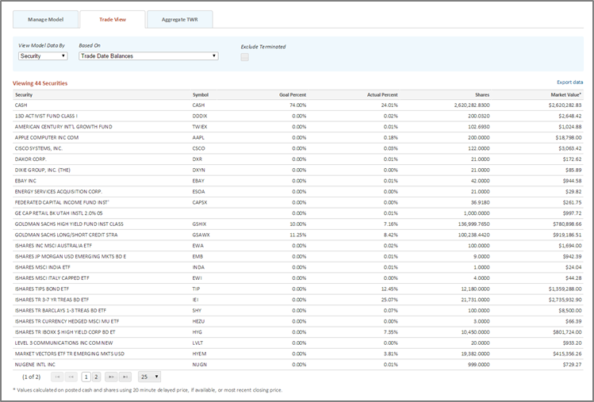

The table shows the following information:
- Security
- Symbol
- Goal Percent
- Actual Percent
- Shares
- Market Value

You can change how you view the model information. For model data, you can view by security, asset or asset subclass information. You can also choose what this data is based on: trade date, trade date excluding recommend trades or settlement date. You can also choose to include or exclude terminating accounts.

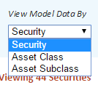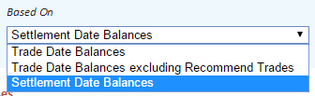
Let you relationship manager know if you have questions regarding this feature now available on Liberty.

