November 2015

Liberty Blotter Report
User Guide

Table of Contents
Navigation 3
Filtering Trade Orders 4
Viewing Blotter Report Selections 5
Defining Options & Creating Blotter Report 6
Retrieving & Viewing Blotter Report 7

Navigation

The Blotter Report is accessed directly from the Trade Blotter. The report provides investment advisors the ability to create and save multiple customized trade reports based on the trade orders currently displayed on the Trade Blotter.
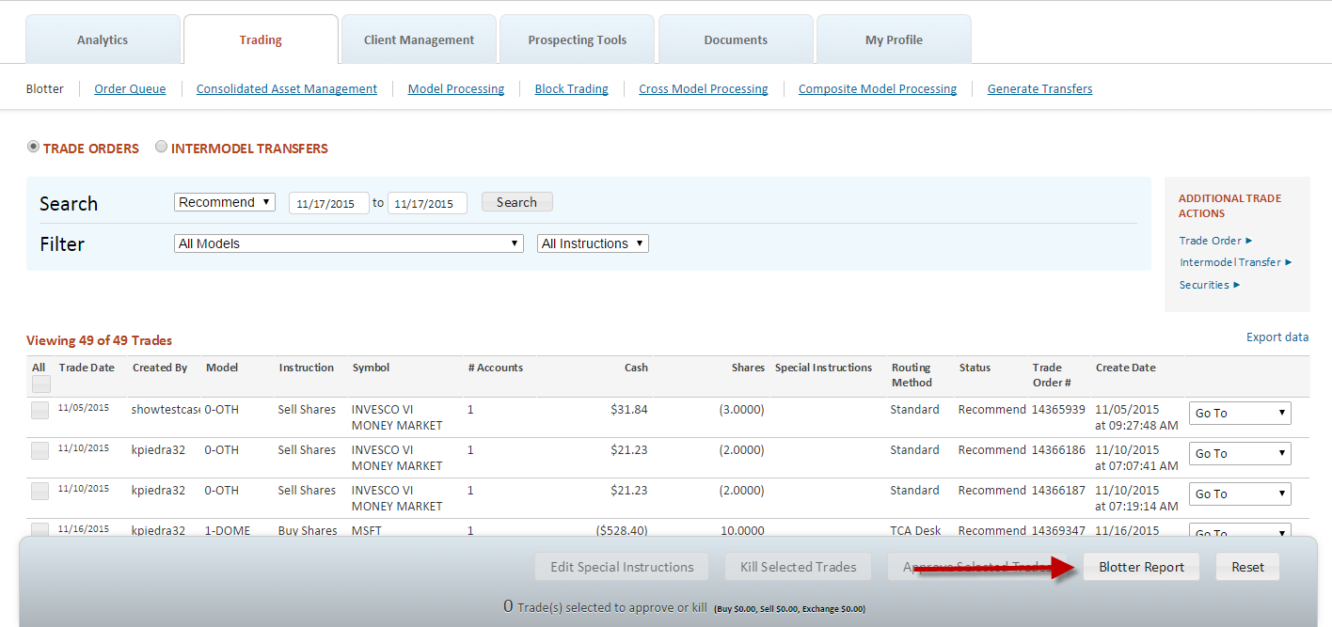
The requested reports may include summary and detail information for the selected trade orders and may be generated in standard spreadsheet or Portable Document Format (PDF) formats.

Filtering Trade Orders

The Blotter Report also includes a Search & Filter option to allow users to limit the display to specific trade orders. Only those records matching the criteria display
Once the search & filter criteria have been defined, click on the All checkbox to include line items from the Trade Order table on the reports. In addition, click on any header to sort the display.
Click on the Blotter Report button in the action bar to proceed to the Blotter Report selection screen.
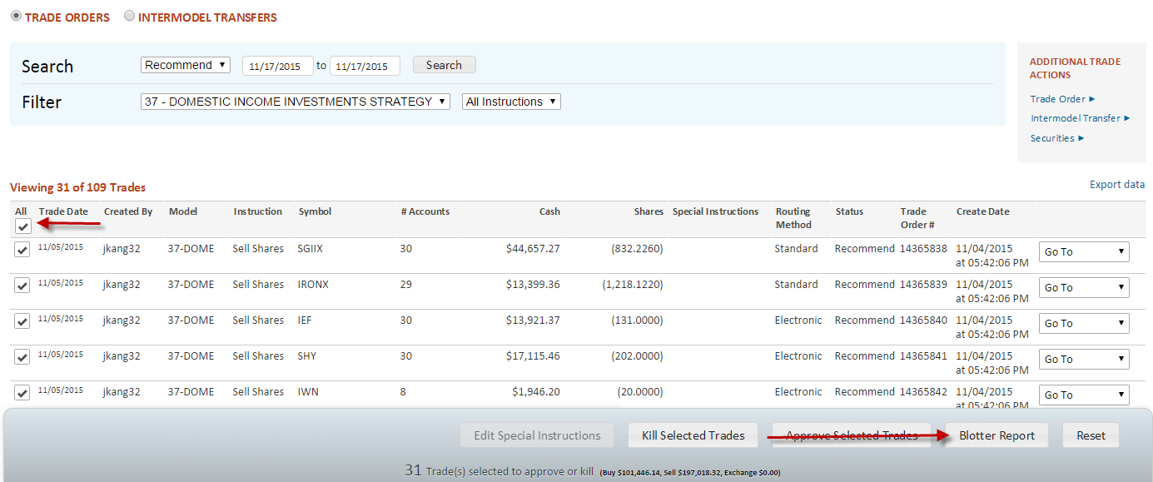

Viewing Blotter Report Selections

The selection screen allows for further filtering and refinement of the selected trade orders for inclusion in the Blotter Report.
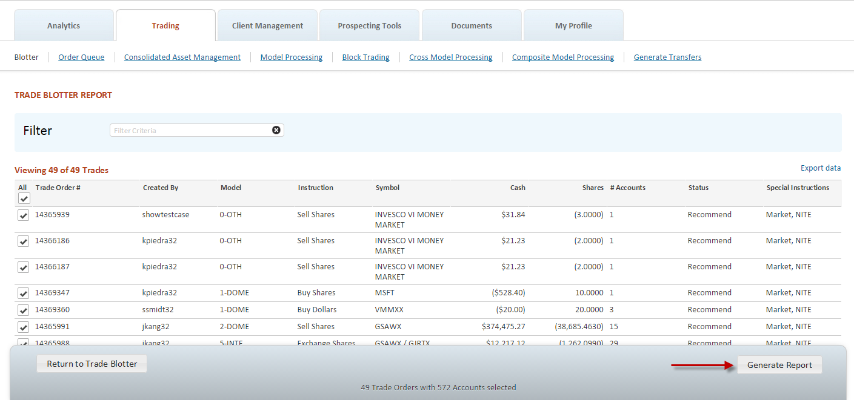
A summary of the requested report options appear in the action bar:
“[number of] Trade Orders with [number of] Accounts selected”
A scroll bar provides users with the ability to move up/down along the selection information.
Standard table export functionality is also available.
Once the selection has been defined, click on “Generate Report” to define Blotter Report options, or alternately click on “Return to Trade Blotter” to leave the selection.

Defining Options & Creating Blotter Report

The default Blotter Report layout option is Trade Order. This will display information on the selected trade orders including the Model, Instruction, Security, Cash, and Shares sorted by Trade Order number.
Selecting the optional Include Account Details layout will display information on the selected trade orders including the Model, Instruction, Security, Cash, Shares as well as details on the underlying accounts sorted by Trade Order number.
The default output file format is Portable Document Format (PDF). The report may also be generated in standard spreadsheet format.
Upon clicking “Create Report”, a confirmation message will appear indicating that report is being processed.
Clicking on the “view completed reports” link will open the “Completed Outputs” page, where the Blotter Report can be retrieved.

Retrieving & Viewing Blotter Report

Once generated, the Blotter Report can be retrieved from the Completed Outputs under the Documents tab.
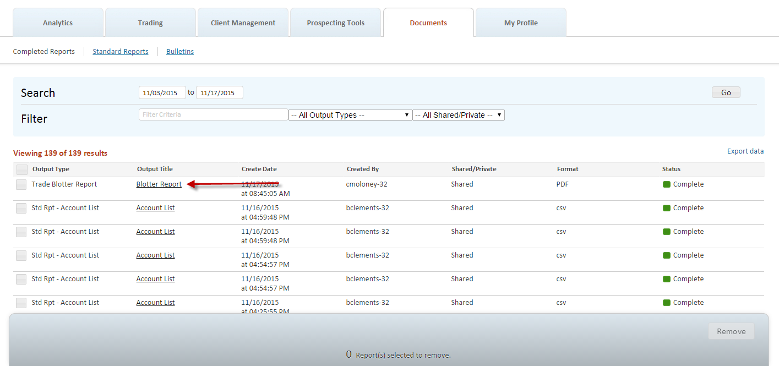
The report can be opened and saved using standard browser functionality.
