January 16

Liberty Order Queue
User Guide

Table of Contents
Quick Start Guide 3
General Usage Notes 3
Messages 4
Navigation 4
Order Queue Overview 5
Search & Filter 6
Refresh Timer Options 7
Order Detail 8
Editing Orders 8
Canceling an Open Order 9

Quick Start Guide

The Order Queue is available in the Trading area of Liberty.
- From the Trading tab, click the Order Queue link to display a list of all open orders.
- Find specific trades by using the search and filter options
- Select an order to view by clicking on it
- Edit or cancel open orders in the Order Details section of the page

General Usage Notes
- Always tab off of or click off of a field after entering data. This tells the Liberty application that you are done entering data in the field and allows it to validate the entry.
- Unlike TCAdvisor, you will be able to edit certain information without clicking an Edit button.
- Error and Informational messages are generally displayed at the top of the screen and contain helpful information regarding errors or actions about to be taken. Please pay special attention to these messages as you complete actions within Liberty.
- Liberty has the same robust user authorizations as TCAdvisor so we can tailor user access to authorize only those areas you deem appropriate.
- As with most web-based applications, you should use the navigation options provided within Liberty rather than your browser’s back button.
- Reset and Cancel actions will not save your changes. Reset will clear any entered data and allow you to start over. Cancel will exit the modification screen without saving your changes. Always tab off of fields after entering information to make sure the information is recorded appropriately.
- Continue saves your changes and automatically navigates you to the next step.
- Save commits your changes. Information is not saved unless you see the confirmation message
- Cancel exits a screen without saving any changes.

Messages
There are several messages you will see as you perform actions within Liberty. In general, messages appear at the top of the screen with a colored background.
Informational messages appear with a blue background and an “I” icon. These messages typically confirm that you have successfully completed some action.
Critical messages appear with a red background and an ‘x’ icon. These messages indicate that something needs to be corrected before you can proceed.

Navigation
The tabs at the top of your screen define major areas of functionality within Liberty
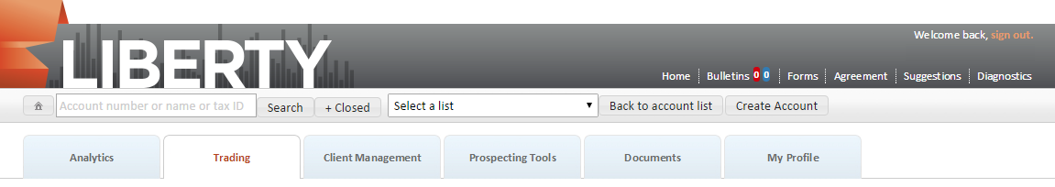
The Trading tab is where you can access the Order Queue. The appearance and available options may vary depending on your role.

Order Queue Overview
All open and current equity orders that have been approved may be viewed from the Order Queue. The screen is divided into sections for viewing Buy and Sell Orders, and Order Details.
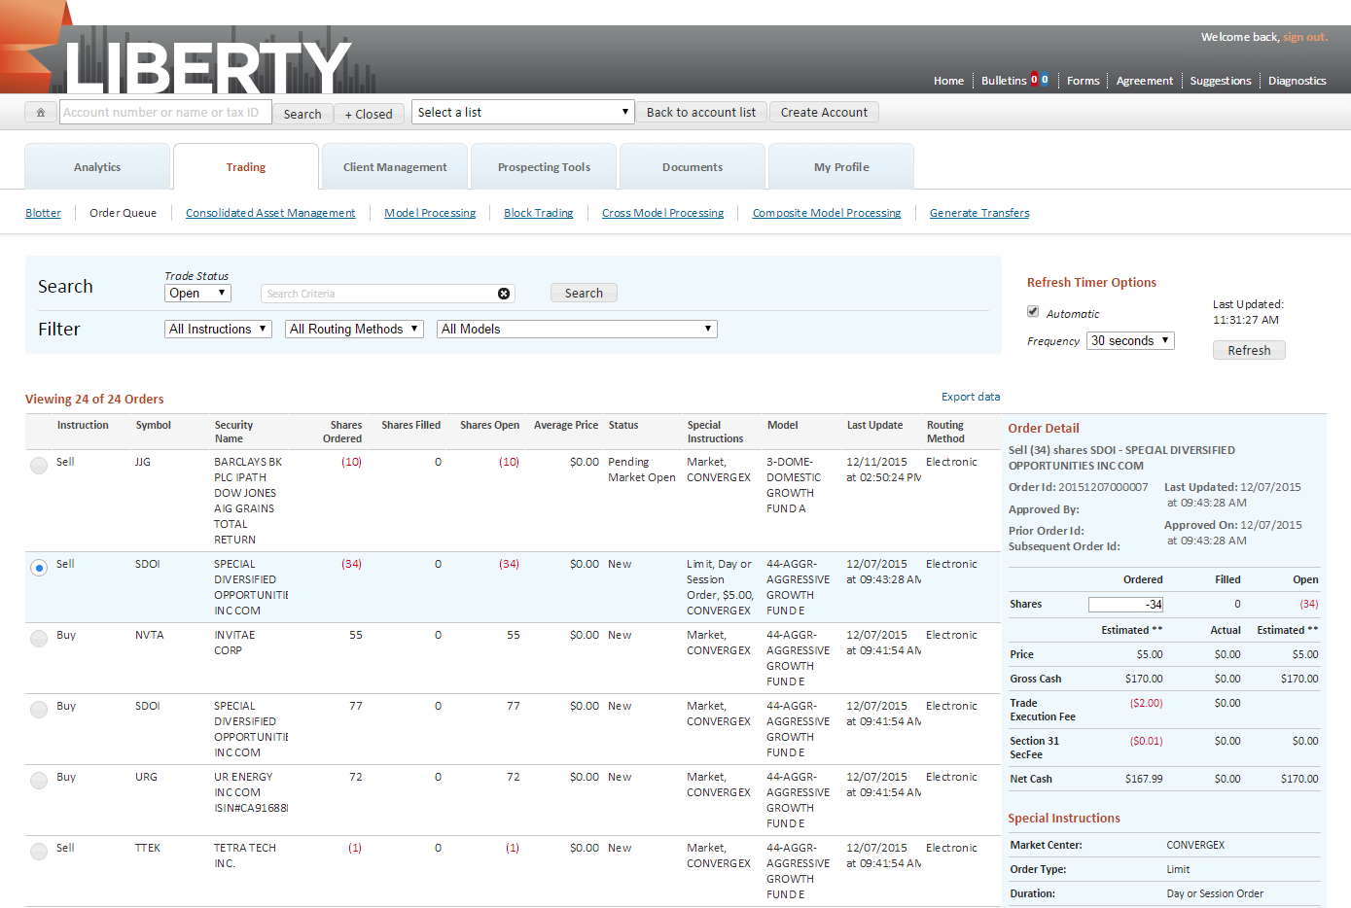
The equity orders will be displayed in descending order based on the time that they were last updated. When using the Managed Electronic routing method, the Summary Managed Electronic order will appear first, followed by the related Detail orders.
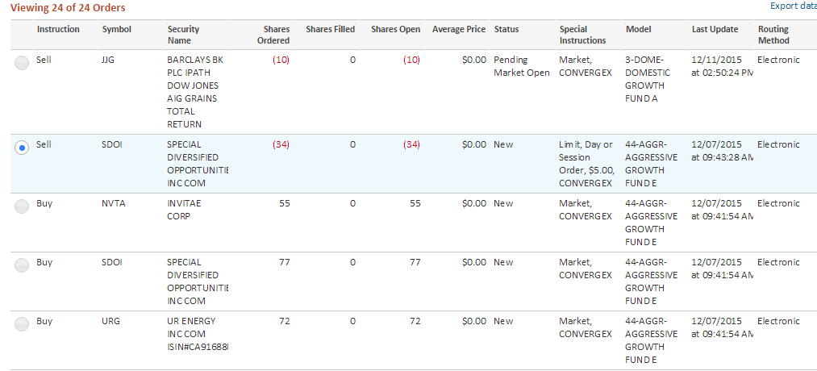
Each order will display the following information:
- Instruction
- Symbol
- Security Name
- Shares Ordered
- Shares Filled
- Shares Open
- Average Price
- Status
- Special Instruction
- Model
- Last Update
- Routing Method

Search & Filter
You may reduce the number of orders displayed in the Order Queue by using several search and filtering options:
- Trade Status: Open or Close
- All instructions; Buys; Sells
- All Routing Methods; Electronic; TCA Desk
- All Models; Specific Model
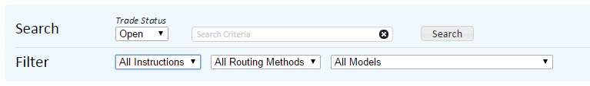

Refresh Timer Options
The screen will default to automatically refreshing every 30 seconds with updated information. You may adjust the refresh timer by choosing a new time from the Frequency drop-down menu. You may also turn off the automatic refresh feature and choose to refresh as needed by clicking the Refresh button.
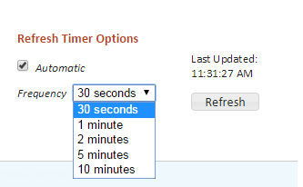

Order Detail
Click an order to display the details in the Order Detail section located on the right side of the screen. Certain orders can be edited from the Order Detail section.
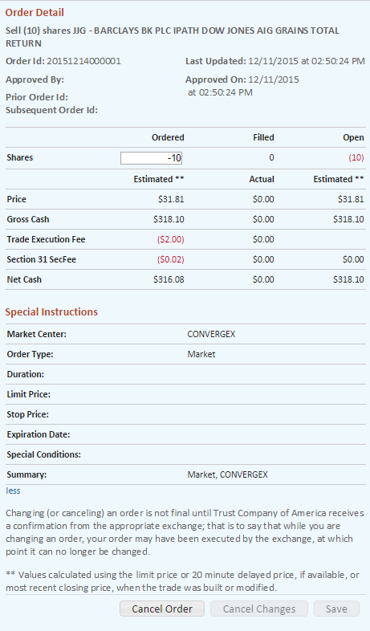

Editing Orders
Only electronically routed equity orders may be modified in the Order Details section. The statuses that are eligible for editing are:
- New
- Partial Fill
- Partial Replace
- Pending Market Open
- Acknowledged
Click on the order you wish to modify. In the Order Details section, you may update the number of Shares ordered. Additionally, if Special Instructions have been defined, you may modify the Order Type, Duration, Limit Price, Stop Limit Price, Expiration Date, and Special Condition.
The display is automatically refreshed with the most recent information from TCAdvisor. Once you are satisfied with the modifications to the order, select the Save button. The new order will reflect a Pending Replace status.

Canceling an Open Order
In order to cancel an open order, it must reflect one of the following statuses:
- New
- Partial Fill
- Pending Replace
- Pending Market Open
- Acknowledged
Click on the order you wish to cancel and select the Cancel Order button located in the Order Detail section. You will be prompted to confirm the cancellation. Once confirmed, the order status will reflect a Canceled status.
Note: A canceled order may or may not be acted upon by TCA depending upon external processes acting upon the order. However, an order may be partially filled and reflect a Canceled status because the portion of the order that is not canceled posts to the underlying accounts. A not held order can be cancelled if the order is electronic and has been approved but not yet filled.

