August 2015

**Liberty Prospecting Tools - Proposals**   
User Guide

Contents

Quick Start Guide 3

General Usage Notes 3

Messages 4

Navigation 4

Proposals Overview 5

Prospecting Tools Tab 5

Search 5

Filter 5

Proposal List 5

Proposal Actions 6

Proposal Steps 7

Summary Text 7

Proposal Information 7

Model Allocations 9

Representatives 10

Proposal Document 11

Branding Specifications 11

Create Account 12

# Quick Start Guide

The following Quick Start Guide provides the basic information you need to get up and running with Proposals on Liberty. Please refer to individual sections for more information.

1. Navigate to Proposals by clicking on the Prospecting Tools tab and selecting the Proposals link.
2. Create a new proposal by clicking the **Create Proposal** button in the action dock.
3. Or edit an existing proposal by clicking the Proposal Name link.
4. The Proposal Information step lets you enter information about the proposal and will be included in the proposal document.
   1. Your custom risk profiles and/or risk profile questionnaire can be built into this step of the process
5. The Model Allocation step will allow you to select models and input allocations.
6. The Representatives step will allow you to select a representative to add to the account
7. Click the **Generate Proposal** button to create your document.

## General Usage Notes

* Always tab off of or click off of a field after entering data. This tells the Liberty application that you are done entering data in the field and allows it to validate the entry.
* Unlike TCAdvisor, you will be able to edit certain information without clicking an **Edit** button. The user documentation gives further information about the specific behaviors you will experience where this sort of editing is allowed.
* Error and Informational messages are generally displayed at the top of the screen and contain helpful information regarding errors or actions about to be taken. Please pay special attention to these messages as you complete actions within Liberty.
* Liberty has the same robust user authorizations as TCAdvisor so we can tailor user access to authorize only those areas you deem appropriate.
* As with most web-based applications, you should use the navigation options provided within Liberty rather than your browser’s back button.
* **Reset** and **Cancel** actions will not save your changes. Reset will clear any entered data and allow you to start over. Cancel will exit the modification screen without saving your changes. Always tab off of fields after entering information to make sure the information is recorded appropriately.
* **Reset** reverts the page to what it was prior to any changes being made.
* **Continue** saves your changes and automatically navigates you to the next step.
* **Save** commits your changes.
  + Information is not saved unless you see the confirmation message
* **Cancel** exits a screen without saving any changes.

## Messages

There are several messages you will see as you perform actions within Liberty. In general, messages appear at the top of the screen with a colored background.

|  |  |
| --- | --- |
| Informational messages appear with a blue background and an “I” icon. These messages typically confirm that you have successfully completed some action. |  |
| Critical messages appear with a red background and an ‘x’ icon. These messages indicate that something needs to be corrected before you can proceed. |  |

## Navigation

The tabs at the top of your screen define major areas of functionality within Liberty



The *Analytics* tab is the landing page for financial professionals, including investment advisors, office managers, and representatives. The appearance and available options may vary depending on your role. You can always return to the *Analytics* tab by clicking on the Home link located under your name in the upper right corner of the Liberty screen.

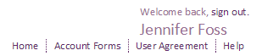

# Proposals Overview

The Proposals tool allows you to create customized investment proposals for your clients. A few pieces of information is all that is required to generate a proposal document, including any marketing collateral and disclosures that you provide, along with information about the selected investment models, including asset allocation information and proposed investment amounts. The document is intended to aid you during the client sales process.

## Prospecting Tools Tab

The *Prospecting Tools* tab provides access to Contacts, Proposals and Prospecting. The appearance and available options may vary depending on your role. Contacts and Prospecting are described in their own user guides.

## Search

You can search your list of proposals by timeframe:

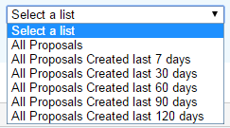

You can also search by:

* Proposal ID
* Proposal Name
* Proposal For

## Filter

You can filter your list of proposals by status:



## Proposal List

The Proposal List displays a list of all proposals you’ve created, along with summary level information about each. The screen also allows you to initiate new proposals or take actions on existing ones.

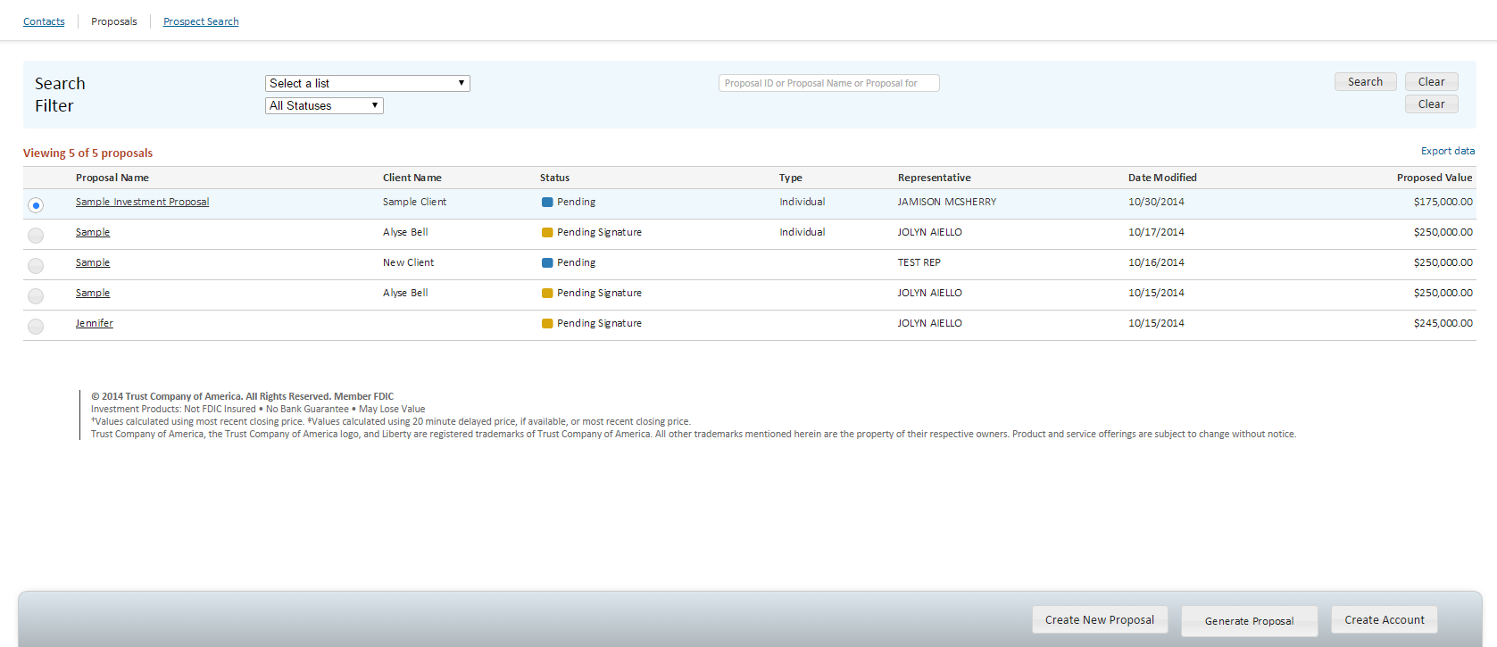

The summary table shows:

* Proposal Name
* Client Name
* Status
* Type
* Representative
* Date Modified
* Proposed Value

## Proposal Actions

Click on the **Create Proposal** button to start the proposal process. Edit an existing proposal by clicking the Proposal Name link.

The action dock allows you to initiate different actions on your proposals by selecting the radio button and clicking the button of the action you want to take.

* **Create Account**: This will open up the Account Registration process, pre-populating the screens with information gathered in the system.
* **Edit**: Takes you to the Proposal Information screen where you can apply changes.
* **Delete**: This will remove the selected proposal from your proposal list. This action should only be taken if a proposal is truly obsolete, as it cannot be reinstated.
* **Generate Proposal**: This will dynamically generate your proposal document in pdf format. This button will be enabled for proposals that have both a model allocation and representative selected.

Each column in the table is sortable. The information in the table can be exported into any of these file formats: .csv, .pdf, .xls, XML.

## Proposal Steps

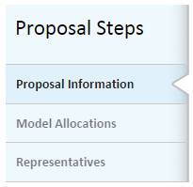

The menu on the left side of the Proposal screens lists the steps the user can follow to complete their proposal. Clicking on a step will navigate you to that step.

## Summary Text



As each step is completed, the text at the top of the screen will be updated. You can review this text to make sure your action will be completed as intended.

## **Proposal Information**

The Proposal Information page captures information about the proposal, the associated client and the proposed account. Only 2 fields are required in order to save your proposal to the system, “Proposal Name” and “Investment Amount”. Once the proposal is saved, it will be assigned a Proposal ID that can be used in other parts of Liberty.

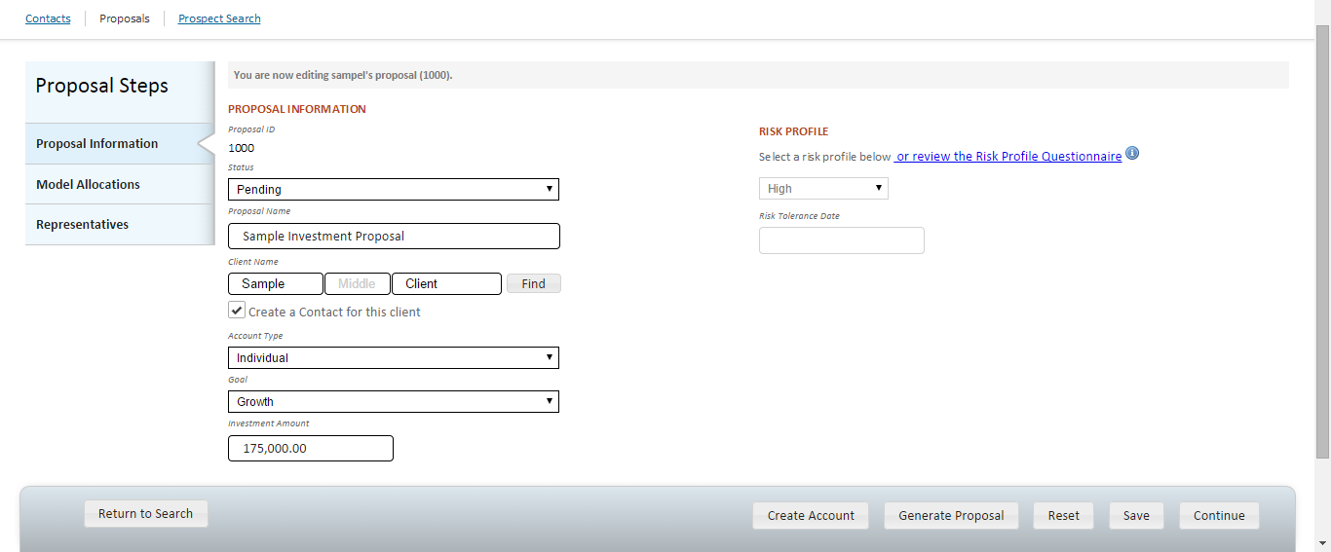

* Status: This will default to Pending however you have the option to update it as needed.
* *Proposal Name:* A required field. The name entered will appear on the cover page of the proposal document. Providing a unique, custom name will help you to easily identify the proposal in your list.
* *Client Name:* Enter in the name of the client you are preparing this proposal for. If you subscribe to Liberty’s Contacts tool, you will be able to search for and/or create contacts directly in Proposals.

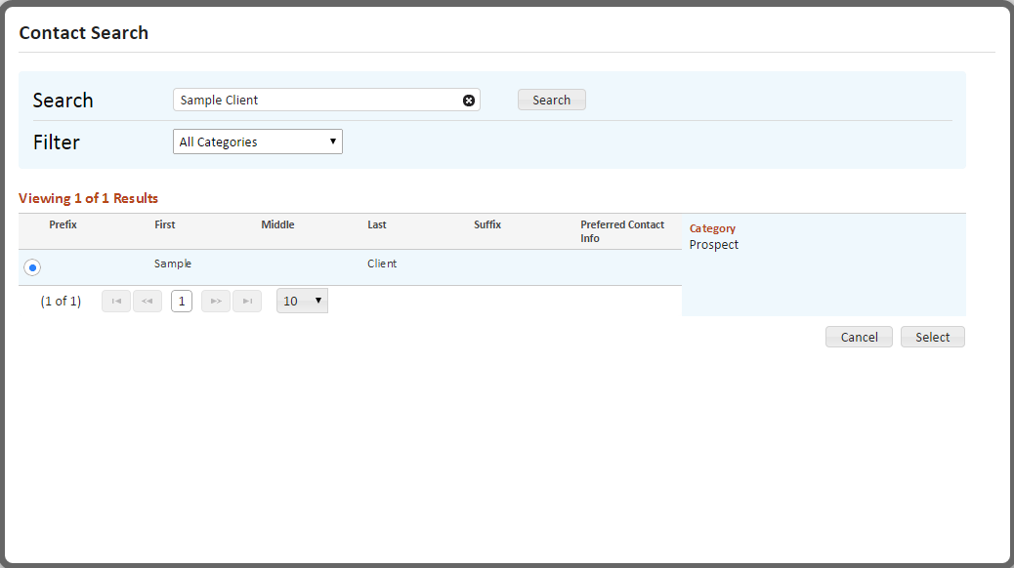

* *Account Type:* If entered, will pre-populate in the Account Registration process.
* *Goal:* Optional choice of Capital Preservation, Growth, Income or Other. Other will dynamically display a field which allows free form text to be entered.
* *Investment Amount:* A required field that is used to show asset allocation information in the proposal document.
* *Risk Tolerance:* Risk Tolerance will display one of two ways, depending on RIA settings.

1. *Risk Tolerance (Client and Spouse):* A field which allows free form text to be entered, to capture the client and/or spouse’s risk profile information.
2. *Risk Profile:* A dropdown that will present a list of risk profiles that the user can select from

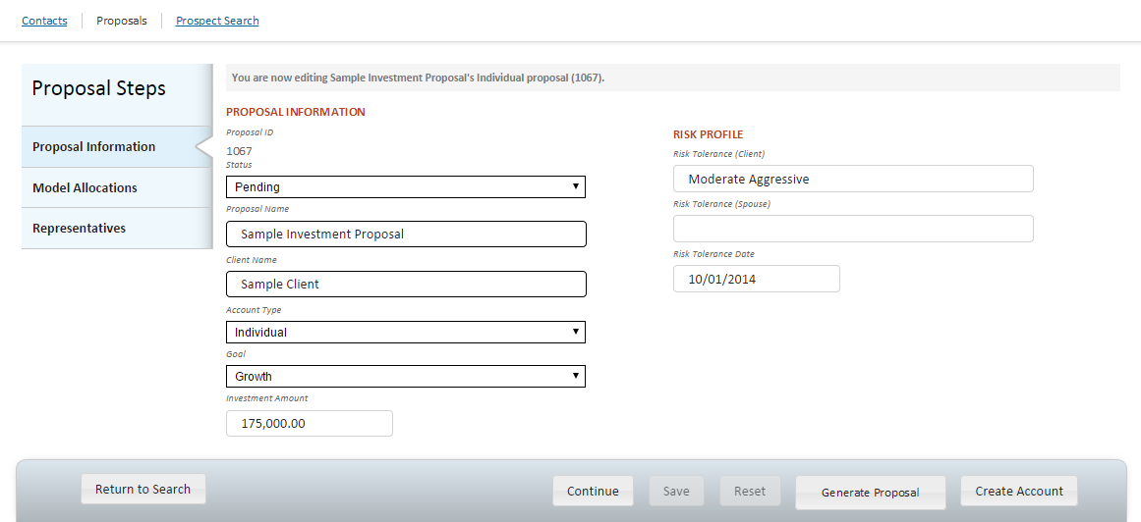 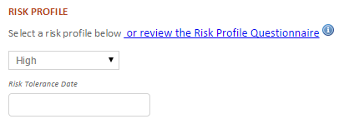

Additionally, a RIA may set up their Risk Profile Questionnaire in Liberty to allow their reps and/or clients to answer a series of questions and determine the risk profile appropriate for them.

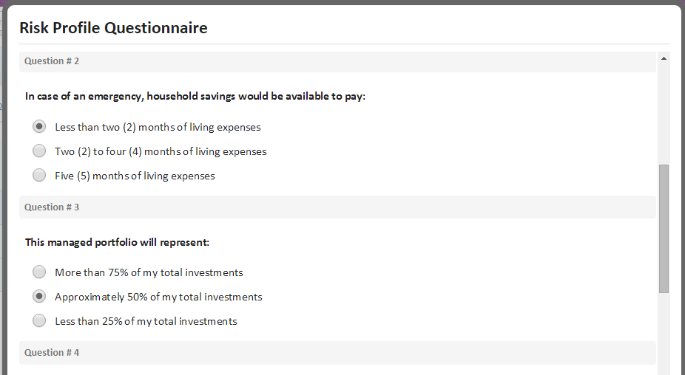

* *Risk Tolerance Date:* Allows the date that the risk tolerance was captured to be entered and saved for tracking purposes.

## Model Allocations

The *Model Allocations* screen allows you to select models to associate to the proposal. The available models come from the allocations stored in the model record maintained on Liberty or TCAdvisor

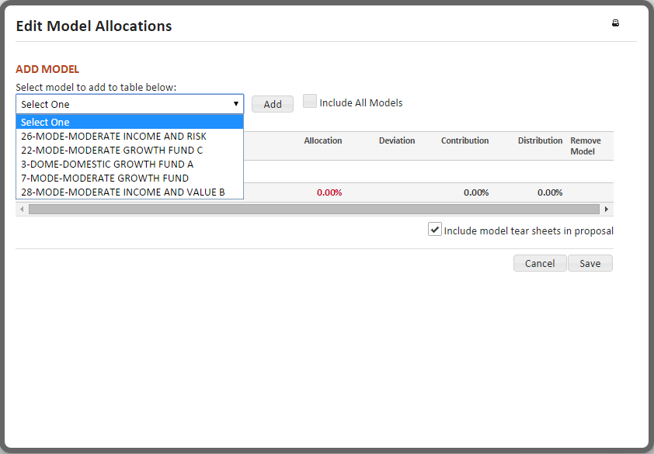

The proposal allows for single or multiple models to be included. Select the **Edit** button to display a list of all models available for selection. If you have selected a risk profile in the previous section, you may see a filtered list of models[1] that have been pre-determined as suitable for the selected risk profile.

Add a model by selecting it from the drop-down and clicking the **Add** button.

To change model allocations, set model instructions or add model comments, click the **Edit** button.

* The Other Assets model is the default model assigned to a new account and cannot be removed.
* **Remove** a model by clicking the  in the far right column.
* Allocation, Contribution and Distribution columns must total 100%.
* Deviation must be a percent between 0% and 5%.

If available, include model tear sheets for all selected models in the Proposal document by selecting the checkbox below the table.

Closing the Model Allocations window will bring you back to the main screen, where you can view a summary of your selections.

## Representatives

On the *Representatives* screen you can add representatives to the account. A representative must be associated to the proposal in order to generate the proposal document.

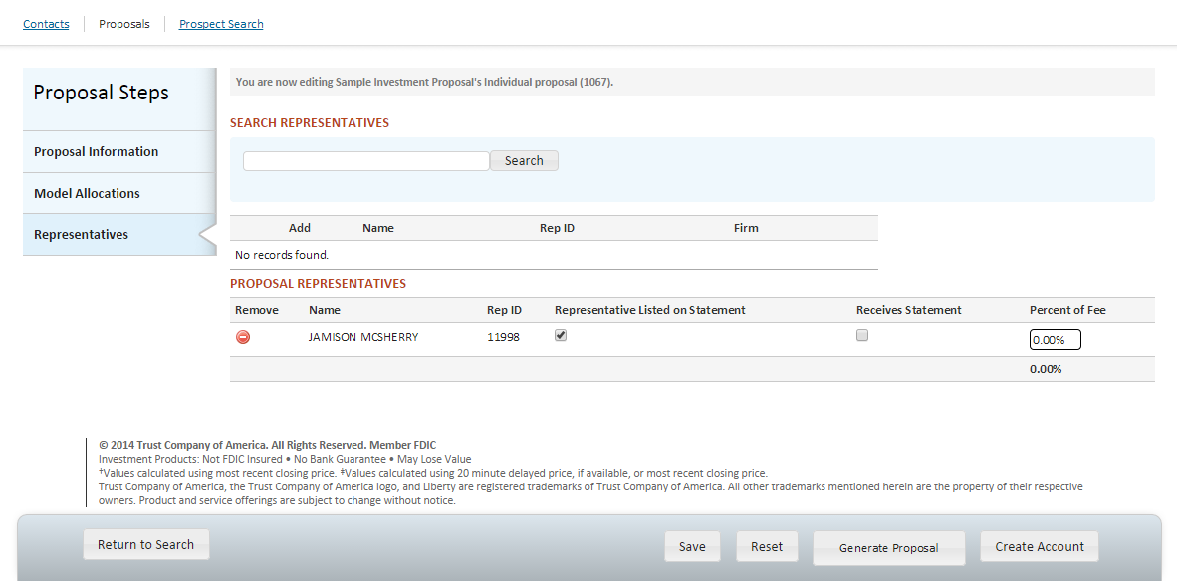

* **Search** retrieves all representatives. To limit the search results, enter all or part of the representative’s name in the Search box.
* Click on the check-box in the left-most column of the search results to view *Representative Details* to confirm you are selecting the correct representative.
* Add representatives by clicking on the  in the search results.
* Remove representatives by clicking on the in the Account Representatives table.
* Representative Listed on Statement must be selected for one representative.
* Receives Statement must be selected for any representatives that need to receive copies of client account statements.
* Percent of Fee column must total either 0% or 100% in order to save.

Once you save the representative to the proposal, by clicking the **Save** button, the **Generate Proposal** button will be enabled. Please note that this document is dynamically generated each time the option is selected and will use current model allocations.

## Proposal Document

The proposal generated is a custom document, allowing for your branding, marketing material(s) and disclosure language applied to the proposal document. Many proposal documents include information about the RIA, their business model, their investment philosophy and/or their model management process, whether internal or with outside money managers. The proposal document layout is as following:

* Cover page
* Advisor or Rep supplied marketing materials
* Liberty Proposal Information
* Liberty Model information
  + Model Summary
  + Individual Model(s)
  + Advisor supplied Model Tear Sheets
* Advisor or Rep supplied disclosure

## Branding Specifications

* Company logo: Displayed as a header on each page of the proposal
  + A 450 x 4800 .png image to allow .75” x 8” display on the proposal with a 600 DPI resolution.
* Marketing collateral: Single or multi-page pdf with a 1.25” top and bottom margin
* Model Tear Sheets: One per model. For composite models, please combine multiple tear sheets into a single pdf. Single or multi-page pdfs with a 1.25” top and bottom margin.
* Disclosure: Single or multi-page pdf with a 1.25” top and bottom margin

*Note: If you currently have branding applied to statements, we should be able to reuse your logo.*

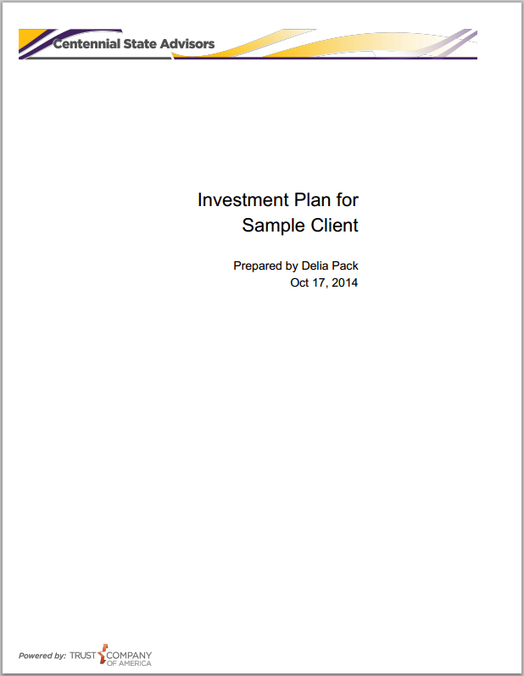

## Create Account

Once a proposal is ready to be turned into an account, select the proposal from your proposal list and click the **Create Account** button. This will bring you into the Account Registration process.

* Information from your proposal, and any associated Contact records, will flow into the Account Registration process, minimizing the amount of information you will need to key into the system.
* You can edit any of the data that has been pre-populated into the screens.
* If eSignature is selected, the proposal document can be optionally included in the DocuSign envelope.
* Please see the Account Creation user guide for more information on the Account Registration process.

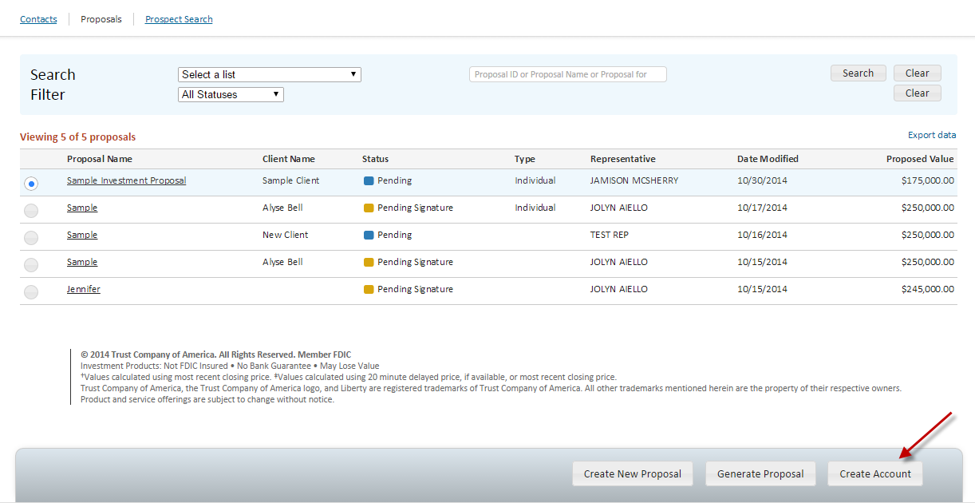

1. A list mapping your risk profiles to suitable models must be provided to TCA to enable this feature