May 2015

Liberty Prospecting Tools: Prospect Search
User Guide

Contents
Quick Start Guide 3
General Usage Notes 3
Messages 4
Navigation 4
Prospect Search Overview 4
Prospecting Tools Tab 4
Search 5
Contact Information 5
Business Profile 6
Specialties 6
Designations 7
Licenses 7
Channel 7
Rep Search Results 8
Rep Profile 9
Create Contact 9
Saved Searches 10
Resources 10

Quick Start Guide
The following Quick Start Guide provides the basic information you need to get up and running with Prospect Search on Liberty. Please refer to individual sections for more information.
- Navigate to Prospect Search by clicking on the Prospecting Tools tab and selecting the Prospect Search link.
- Search by entering one or more search criteria and clicking the Search button.
- Click on a name to view the Rep Profile .
- Save a Search for future use
- Use Resources to aid in your prospecting efforts
- Create Contacts to track your activity

General Usage Notes
- Always tab off of or click off of a field after entering data. This tells the Liberty application that you are done entering data in the field and allows it to validate the entry.
- Unlike TCAdvisor, you will be able to edit certain information without clicking an Edit button. The user documentation gives further information about the specific behaviors you will experience where this sort of editing is allowed.
- Error and Informational messages are generally displayed at the top of the screen and contain helpful information regarding errors or actions about to be taken. Please pay special attention to these messages as you complete actions within Liberty.
- Liberty has the same robust user authorizations as TCAdvisor so we can tailor user access to authorize only those areas you deem appropriate.
- As with most web-based applications, you should use the navigation options provided within Liberty rather than your browser’s back button.
- All checkboxes will select all options in the applicable section.
- Reset and Cancel actions will not save your changes. Reset will clear any entered data and allow you to start over. Cancel will exit the modification screen without saving your changes. Always tab off of fields after entering information to make sure the information is recorded appropriately.
- Reset reverts the page to what it was prior to any changes being made.
- Cancel exits a screen without saving any changes.
- Save commits your changes.
  - Information is not saved unless you see the confirmation message
- Continue saves your changes and automatically navigates you to the next step.

Messages
There are several messages you will see as you perform actions within Liberty. In general, messages appear at the top of the screen with a colored background.
Informational messages appear with a blue background and an “I” icon. These messages typically confirm that you have successfully completed some action.
Critical messages appear with a red background and an ‘x’ icon. These messages indicate that something needs to be corrected before you can proceed.

Navigation
The tabs at the top of your screen define major areas of functionality within Liberty
The Analytics tab is the landing page for financial professionals, including investment advisors, office managers, and representatives. The appearance and available options may vary depending on your role. You can always return to the Analytics tab by clicking on the Home link located under your name in the upper right corner of the Liberty screen.

Prospect Search Overview
The Prospect Search tool allows you to search a database of over 590,000 registered representatives, narrowing results to fit within criteria you designate. Trust Company of America has integrated with Meridian-IQ, an industry leader of registered representative research, to provide access to representative information with Liberty.

Prospecting Tools Tab

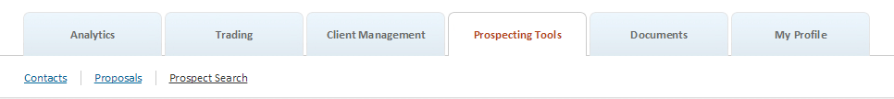

The Prospecting Tools tab provides access to Contacts, Prospect Search and Prospecting. The appearance and available options may vary depending on your role. Contacts and Proposals are described in their own user guides.

Search
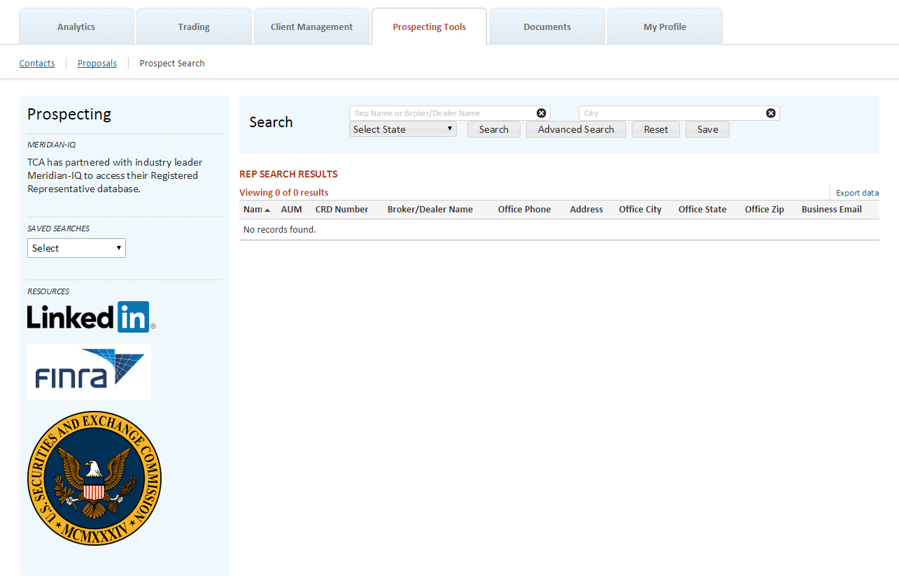
Searching for prospects can be done in many different ways. The search criteria take into account some of the most commonly known information about representatives. Select search elements from any of the categories, in any type of combination. Run different searches and create marketing efforts around the results.

Search
Basic Search is appropriate for broad searches on:
- Name (Representative or Broker/Dealer)
- City
- State

To search on more specific criteria, use the Advanced Search option.

Advanced Search: Contact Information
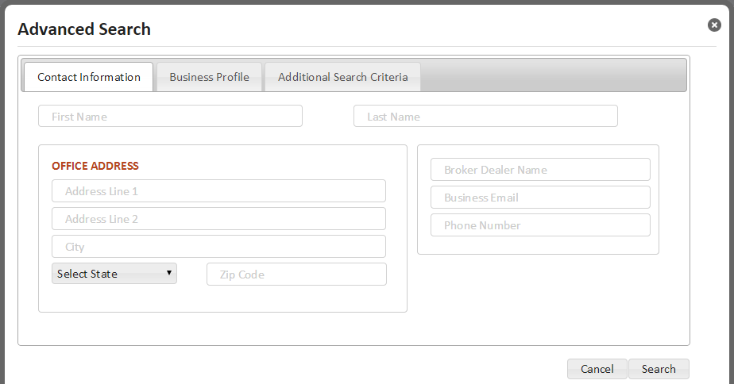
Contact Information lets you search for representatives based on:
- First Name
- Last Name
- Office Address Line 1
- Office Address Line 2
- Office City
- Office State
- Office Zip
- Broker/Dealer Name
- Business Email
- Office Phone Number

Advanced Search: Business Profile
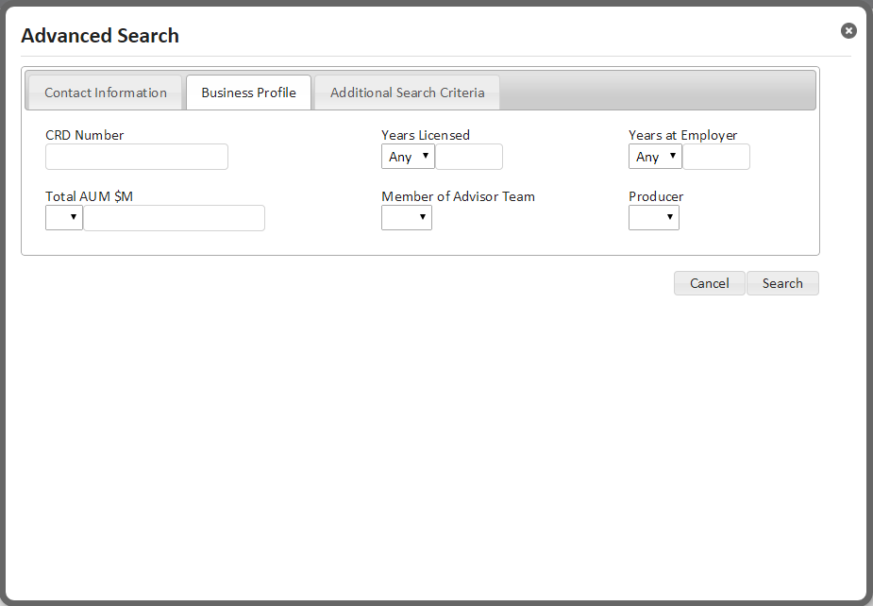
Business Profile lets you search for representatives based ranges of information:
- CRD Number
- Years Licensed using greater than, less than or equals to parameters
- Years at Employer using greater than, less than or equals to parameters
- Total AUM using greater or less than parameters
- Member of Advisor Team
- Producers

Advanced Search: Additional Search Criteria
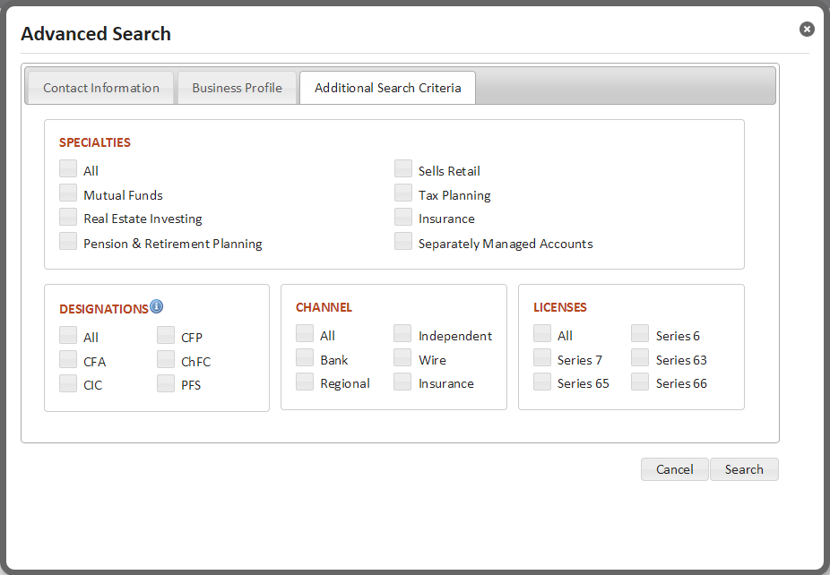

Specialties
Including specialties criteria in your search allows you to narrow your results to specific areas of expertise:
- Sells Retail
- Mutual Funds
- Separately Managed Accounts
- Insurance
- Pension & Retirement Planning
- Real Estate Investing
- Tax Planning

Designations
The following designations can be selected for inclusion in your search via check box:
- Certified Financial Planner - CFP
- Chartered Financial Analyst - CFA
- Chartered Financial Consultant - ChFC
- Chartered Investment Counselor - CIC
- Personal Financial Specialist - PFS

Channel
The following licenses can be selected for inclusion in your search via check box:
- Bank
- Independent
- Insurance
- Regional
- Wire

Licenses
The following licenses can be selected for inclusion in your search via check box:
- Series 6: Investment Company and Variable Contracts Products Representative
- Series 7: General Securities Representative
- Series 63: Uniform Securities Agent State
- Series 65: Uniform Investment Adviser Law
- Series 66: Uniform Combined State Law

Modify Search

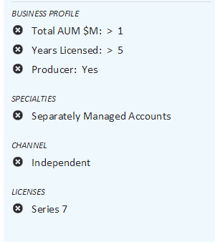
- For your convenience, all search criteria that was used in your search will be shown in a panel on the left-hand side of the screen
- To remove criteria from your search, simply click the “x” icon. Your search will automatically be rerun using the remaining criteria

Rep Search Results
The Rep Search results display all reps who meet any of the criteria you’ve included in the search.
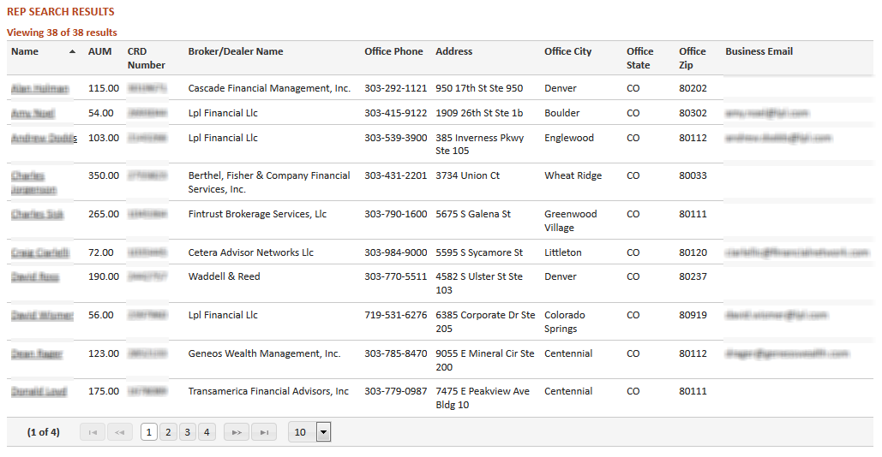
The summary table shows:
- Name
- AUM
- CRD Number
- Broker/Dealer Name
- Office Phone
- Address
- Office City
- Office State
- Office Zip
- Business Email
Each column in the table is sortable.
Select a specific representative to view by clicking on their name.

Rep Profile
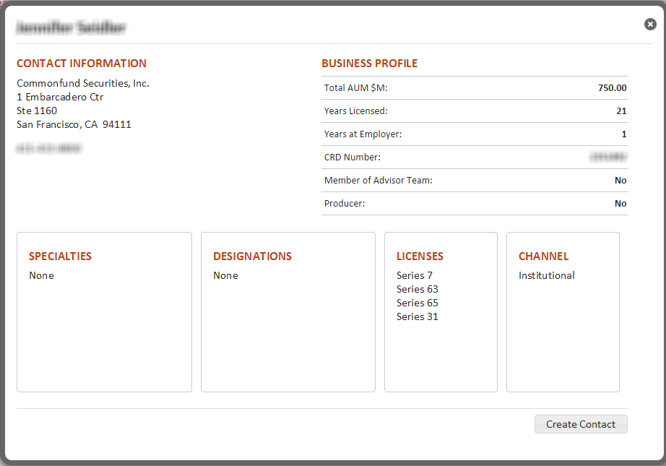
- The Rep Profile provides a greater level of detail on the selected rep.
- The profile does not take into account any search criteria used, it will display all available information.
- Licenses held, outside of those available in the Search feature, will also be displayed.

Create Contact
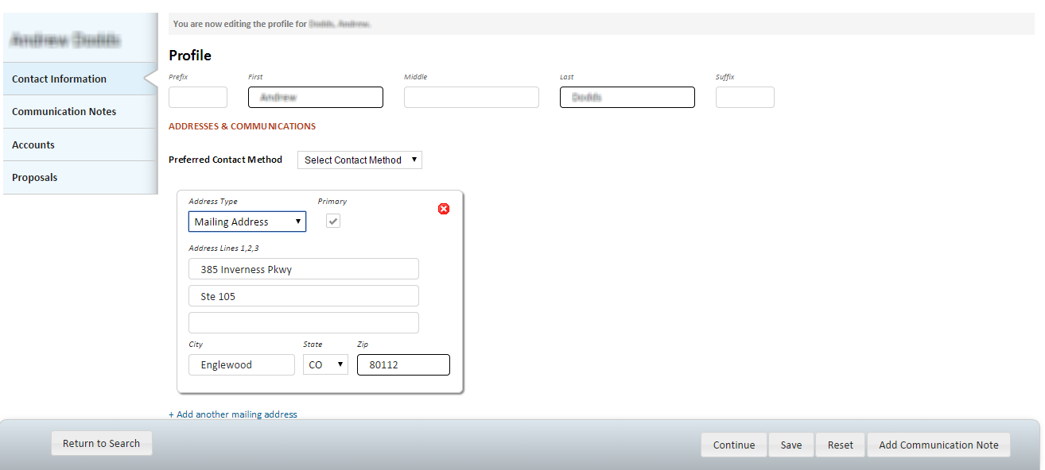
- Easily add prospect information to your Contacts by clicking the Create Contact button.
- Navigate to the Contacts page to access the record.

Saved Searches
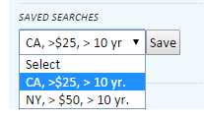
- You can save your search criteria for future use.
- For ease of use, consider using descriptions that will help you easily identify the goal of the search.

Resources
- A link to LinkedIn has been provided for your use while prospecting. Many representatives maintain profiles on the site.
- It’s always a good idea to check a rep’s background out before spending time and effort prospecting to them.
  - A link to FINRA’s BrokerCheck site has been provided.
  - A link to the SEC’s Investment Adviser Public Disclosure site has been provided.

