August 2015

Liberty Analytics
User Guide
Investment Advisor Edition

Table of Contents
Summary Analytics Section 4
Liberty Rep Analytics 8
Navigation 9
Persisted Selections 9
Drill-Down 10
Averages 11
View Details 12
Average Accounts Per Representative 13
Year End Average Account Size 14
Year End Average AUM Per Representative 15
Average Accounts Opened and Closed Per Representative 16
Leaderboard 17
Leaderboard Table View 18
Leaderboard Periodicity 19
Ranking by Office 19
Growth 21
Growth – Chart View 22
Growth – Detail View 22
Tablet Navigation 23
Optional Configuration – Aggregate Multiple Rep Records 24
Representative View 25
Averages 25
Leaderboard - Representative Name Display 26
Growth 27
Business Rules 28
General 28
Account Changes 28
Accounts with Multiple Representatives 28

Summary Section
The Summary section provides investment advisors with a tool to view statistical and quantitative analysis on their account base in order to make better business decisions and to optimize business processes. It is composed of three sub-sections:
- Current Statistics
- Activity Over Time
- Analytics Detail
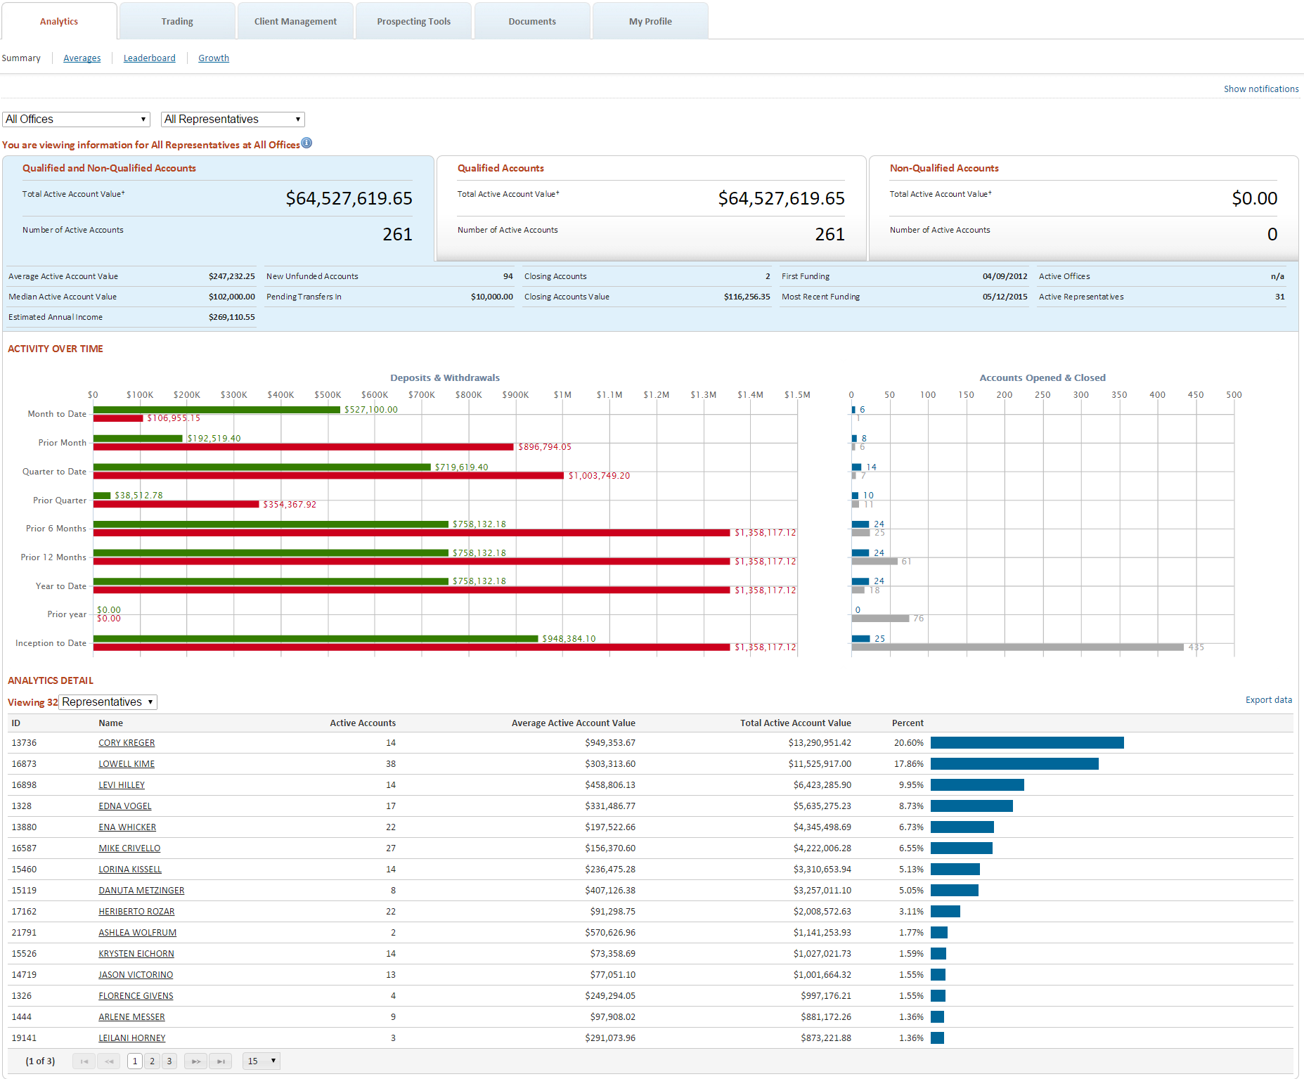

Current Statistics
Current statistics, located in the upper section of the Analytics homepage, shows summaries of your account value, activity, holdings and details. The section consists of three panels allowing you to view current statistics in terms of All Accounts, or broken down into either Qualified or Non-Qualified Accounts. The active selection will be highlighted in blue.
All Accounts:
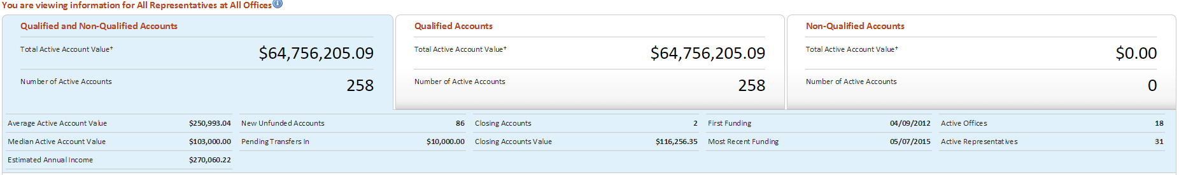
Qualified Accounts:
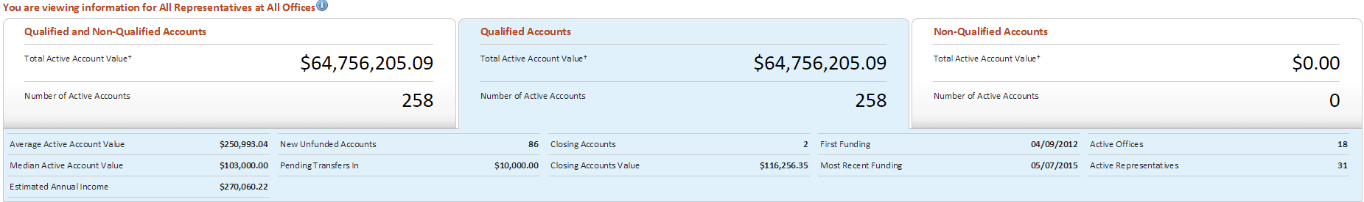
Non-Qualified Accounts:
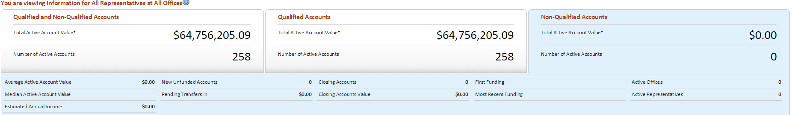

Activity Over Time
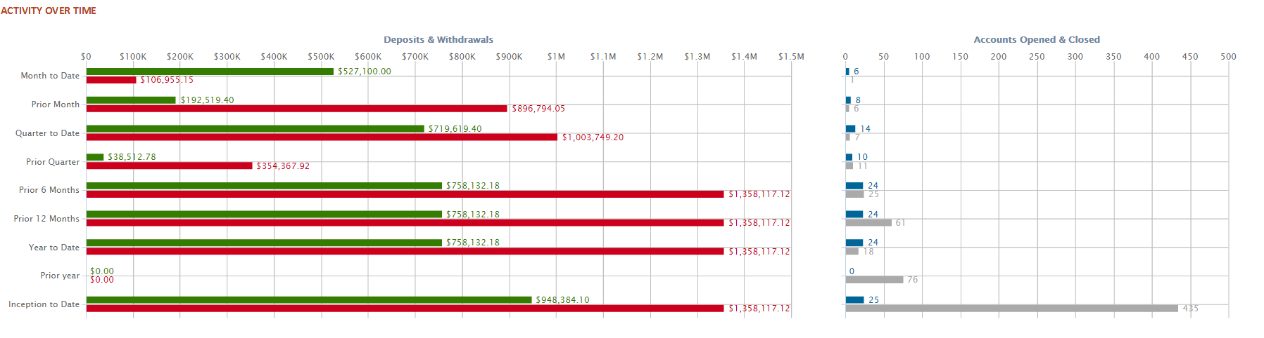
Activity Over Time shows Deposit & Withdrawal activity and Accounts Opened & Closed activity for predefined time-periods.
Analytics Detail
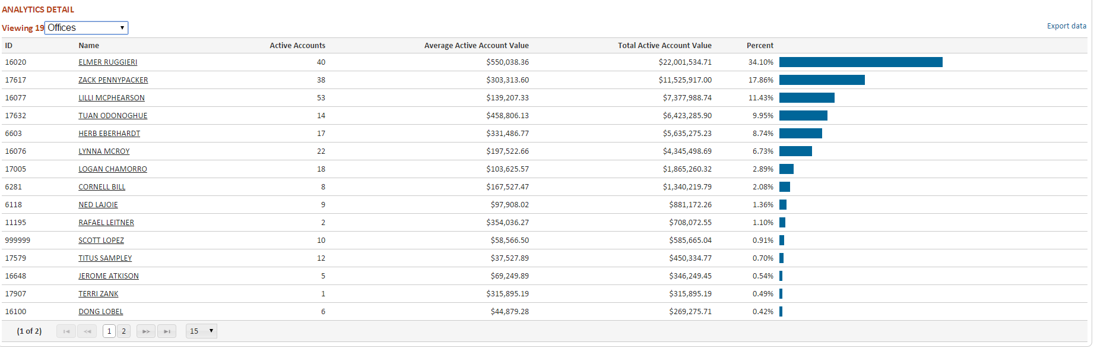
The Analytics Detail table displays key information of Offices, Representatives and Investors. The table allows you to drill down through your book of business with just a few clicks:
All Offices Office All Representatives Representative Investors Account

View More
Contact details and other information for Offices and Representatives can be viewed by clicking on the View More link
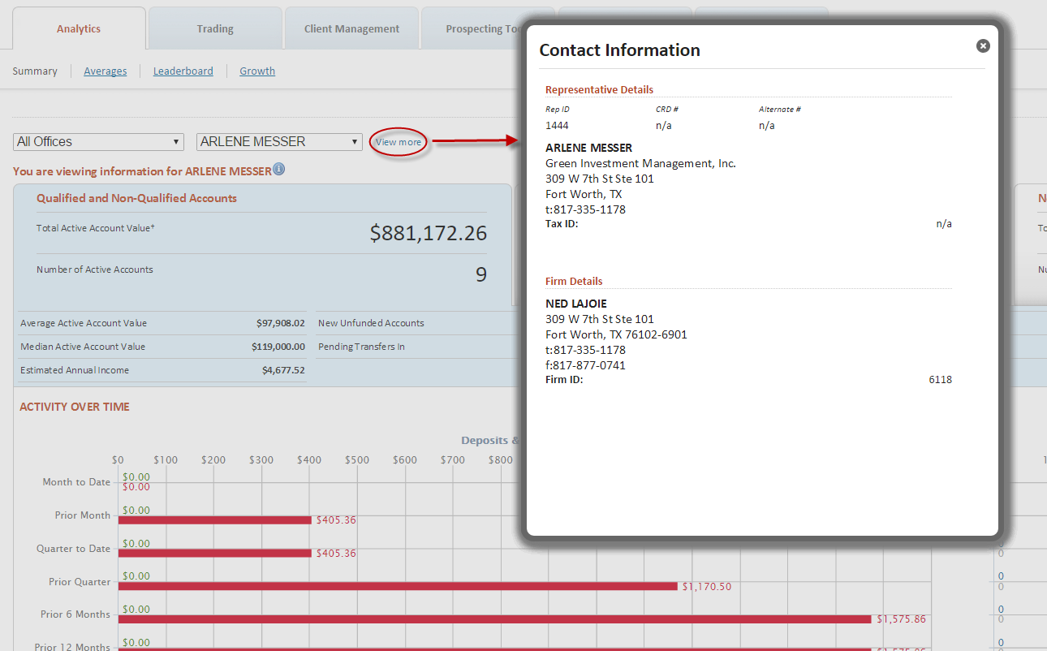

Liberty Rep Analytics
The Remainder of this user guide refers to Liberty Rep Analytics, a subscription-based data set. If you would like to learn more about this premium offering, please contact your Relationship Manager.

Navigation
Analytics navigation is optimised for ease of use in order to provide an efficient workflow. Basic nagigation consists of three sun-navigations:
- Averages
- Leaderboard
- Growth

Persisted Selections
Any selection from the Office or Representative dropdown controls will persist across Analytics navigation, thus painting a more rounded picture of the representative’s performance:
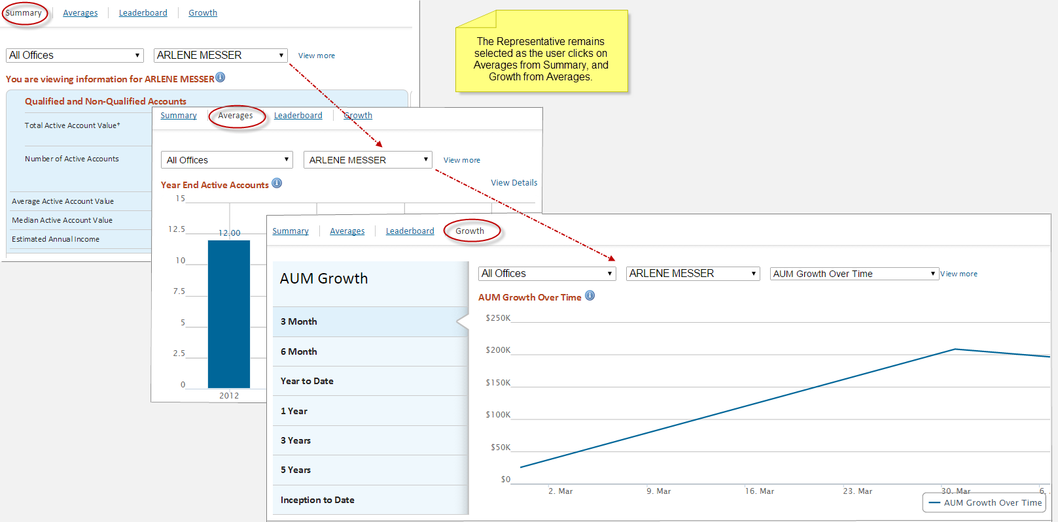

Drill-Down
Leaderboard
Representative and Office names are linked from the Leaderboard to their respective Summary pages.
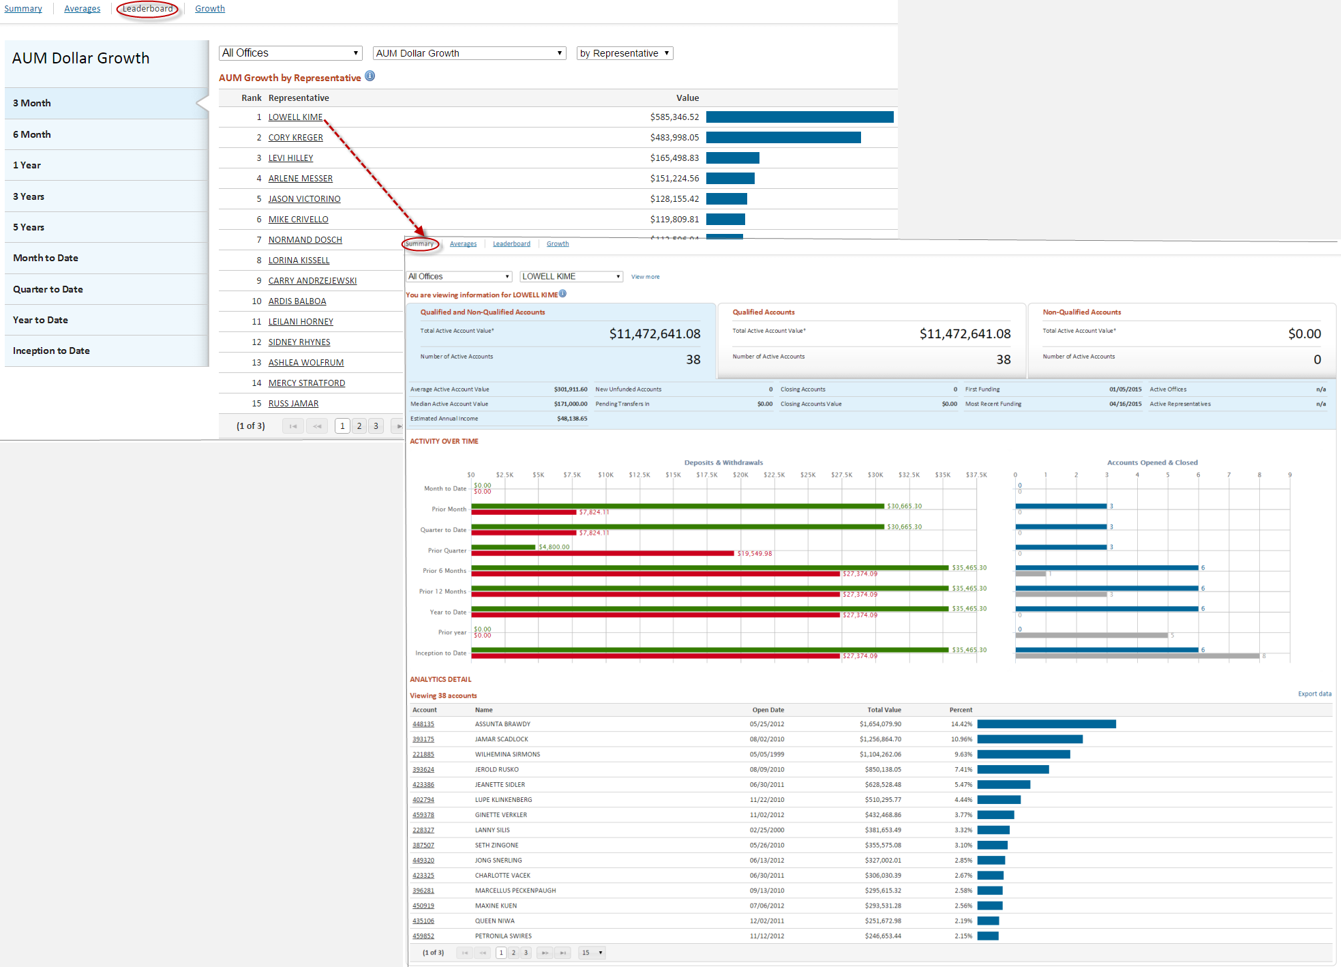

Averages
The Averages section provides snapshots of representatives’ performance at fixed points in time. It is made up of the following bar graphs:
- Average Accounts Per Representative
- Year End Average Account size
- Year End Average AUM Per Representative
- Average Accounts Opened and Closed Per Representative
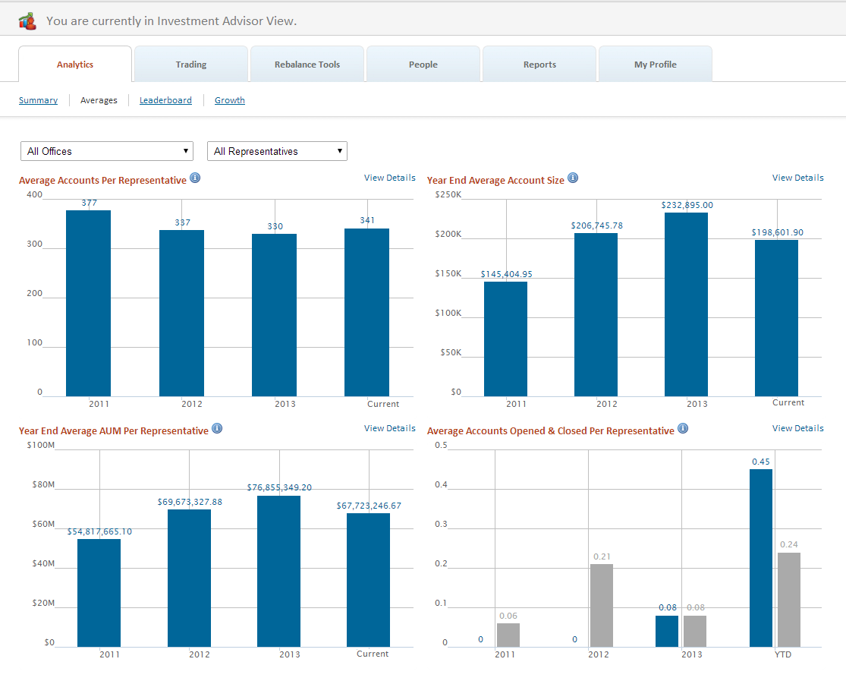
Average metrics are available at IA, Office and Representative levels.

Information Icon
Each bar graph title contains an information icon which expands to display the data definition for the metric in question.
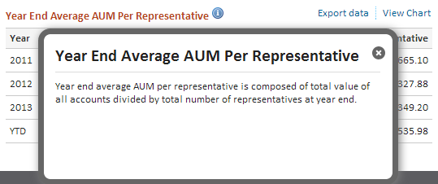

View Details
Click on the View Details link to view the underlying data of the bar graph.
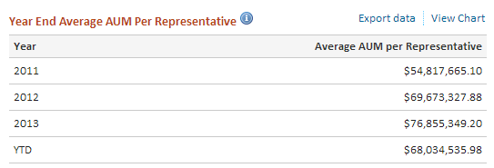

Average Accounts Per Representative

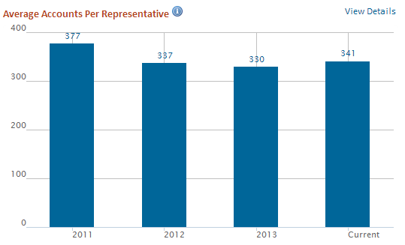
Year-end Average Accounts Per Representative is composed of the total number of active accounts divided by the number of active representatives.

Year End Average Account Size

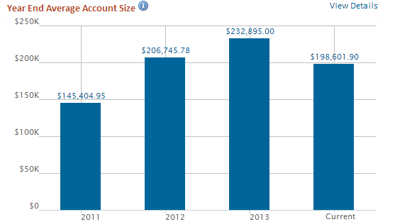
Year-end Average Account size is composed of the total value of all active accounts divided by the number active of accounts.

Year End Average AUM Per Representative

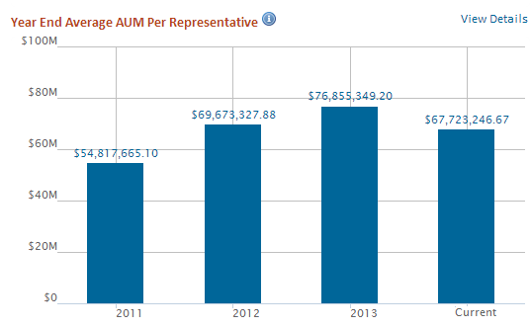
Year-end Average AUM Per Representative is composed of the total value of all active accounts divided by the number of active representatives.

Average Accounts Opened and Closed Per Representative

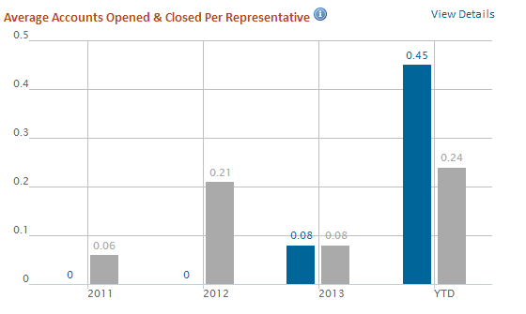
Year-end Average Number of Accounts Opened and Closed Per Representative is composed of the total number of accounts opened during the period divided by number of active representatives at year end, and total number of accounts closed during the period divided by number of active representative at year end.

Leaderboard
The Leaderboard displays representative & office level growth relative to their peers. Ranking metrics are available in both absolute and percentage terms for the following items:
- AUM Dollar Growth
- AUM Percentage Growth
- Closed Accounts
- Gross Deposits
- Net Deposits
- Net New Accounts
- New Accounts
- Withdrawals
- Period Over Period Deposit Trends
- Period Over Period Net Deposit Trends
- Period Over Period New Account Trends
- Period Over Period Withdrawal Trends

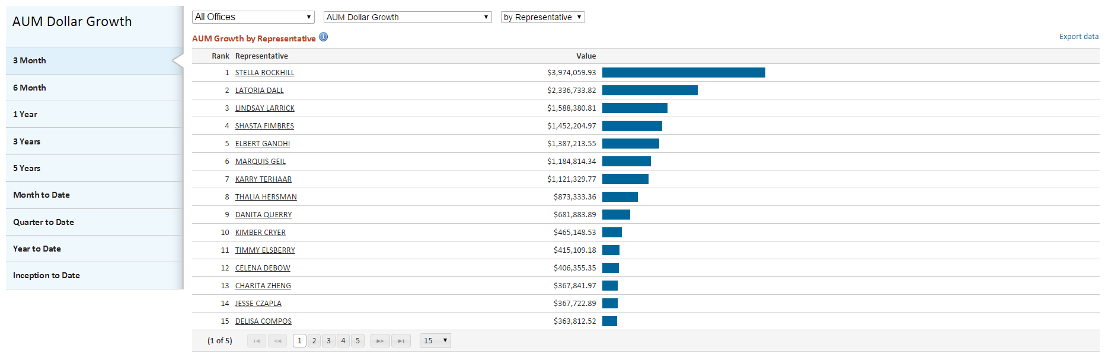
Leaderboard metrics are available at IA and Office levels

Leaderboard Table View
Each Leaderboard table is made up of the following items
- Rank – The Representative’s rank relative to their peers at the same firm
- Representative Name *
- Value – The Dollar or percent value of the selected metric
- Relative Performance Graph - A visual representation of the metric against a baseline of 100
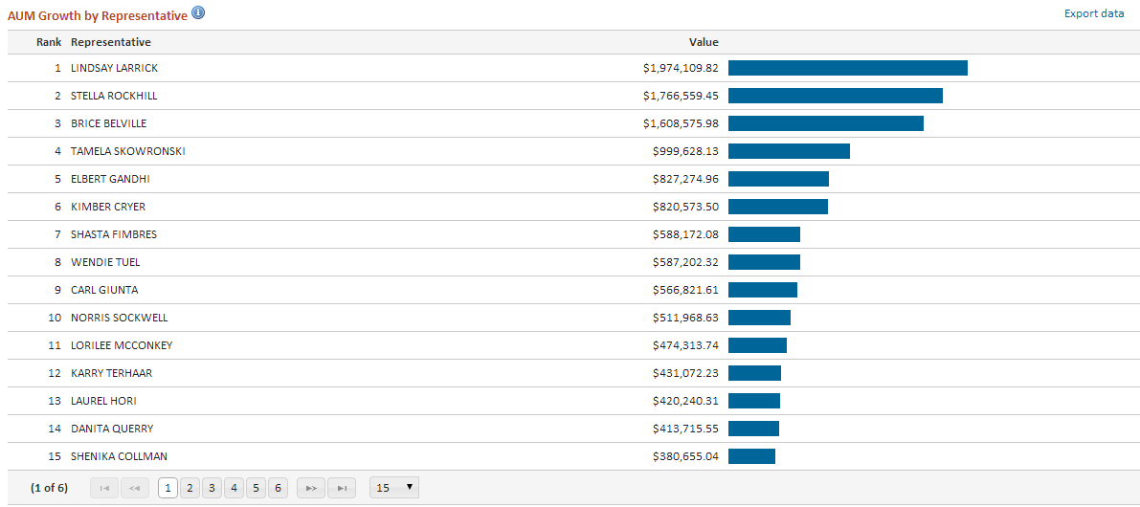

*Representative Name can be anonymized

Leaderboard Periodicity
Available periods for metrics are displayed on the sidebar. The sidebar will adjust to the number of periods available for each specific metric.
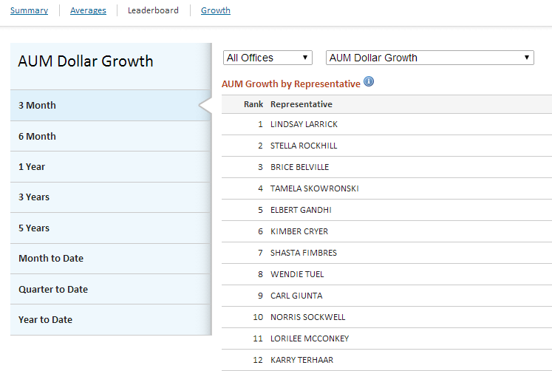

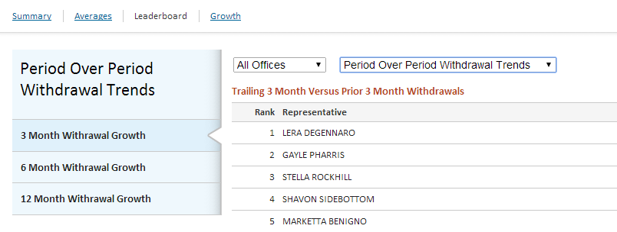
Ranking by Office
Offices can be ranked and compared by selecting the “By Office” option. Ranking metrics are available in both absolute and percentage terms for the following items:
- AUM Dollar Growth
- AUM Percentage Growth
- Closed Accounts
- Gross Deposits
- Net Deposits
- Net New Accounts
- New Accounts
- Withdrawals
- Period Over Period Deposit Trends
- Period Over Period Net Deposit Trends
- Period Over Period New Account Trends
- Period Over Period Withdrawal Trends
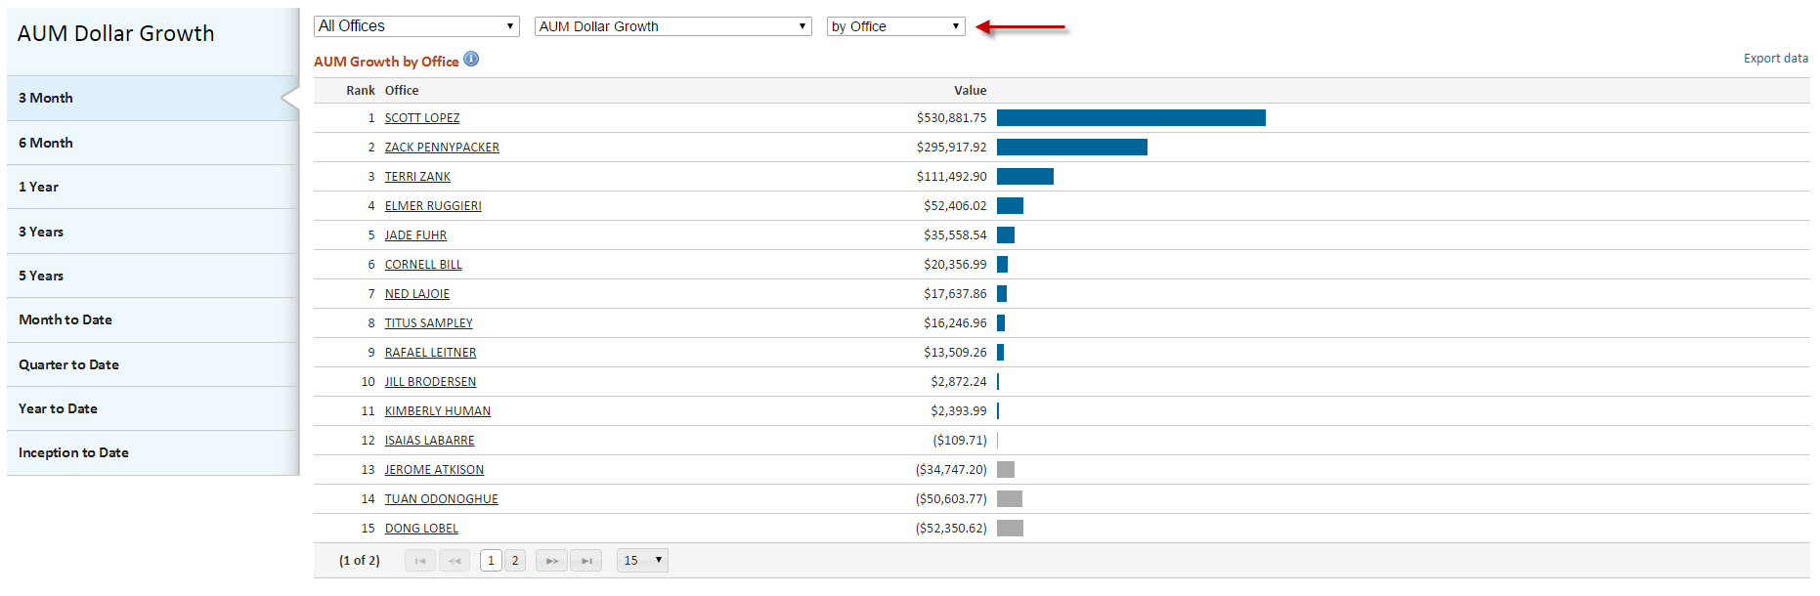

Growth
The Growth section displays values for each month in the time period selected, and provides a view of performance over time. Growth metrics are available in both absolutes and percentage terms for the following items:
- AUM Growth Over Time
- Percentage AUM Growth Over Time
- Deposit Growth
- Withdrawal Growth

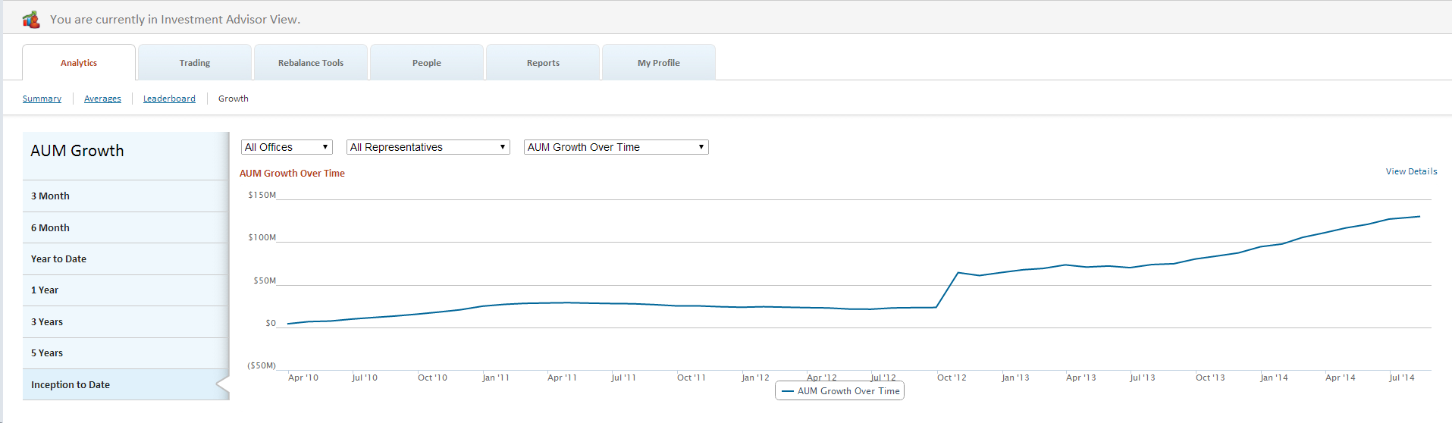
Growth metrics are available at IA, Office and Representative levels.

Growth – Chart View
The default view displays growth over time in chart format.

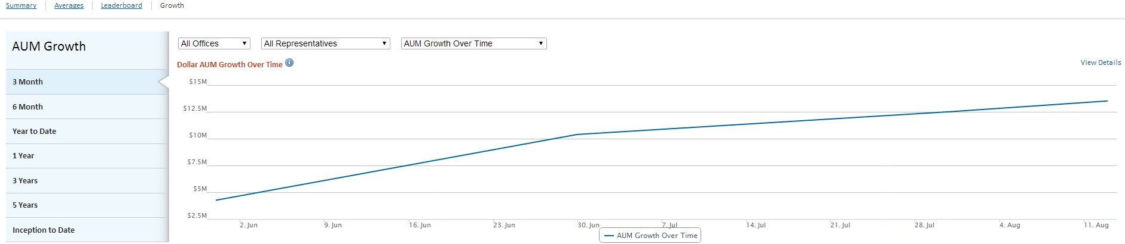

Growth – Detail View
Click on the View Details link to view the underlying data of the chart.

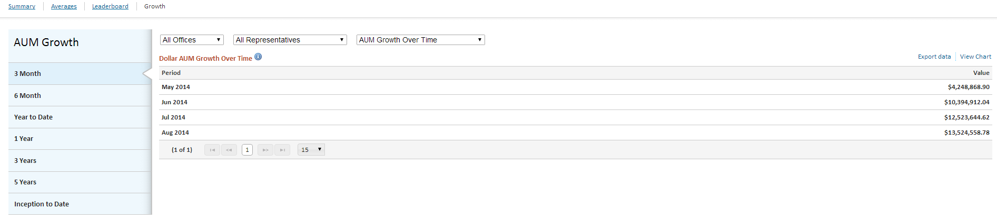

Tablet Navigation
The tablet version of Analytics retains all features and functionality of the desktop version.
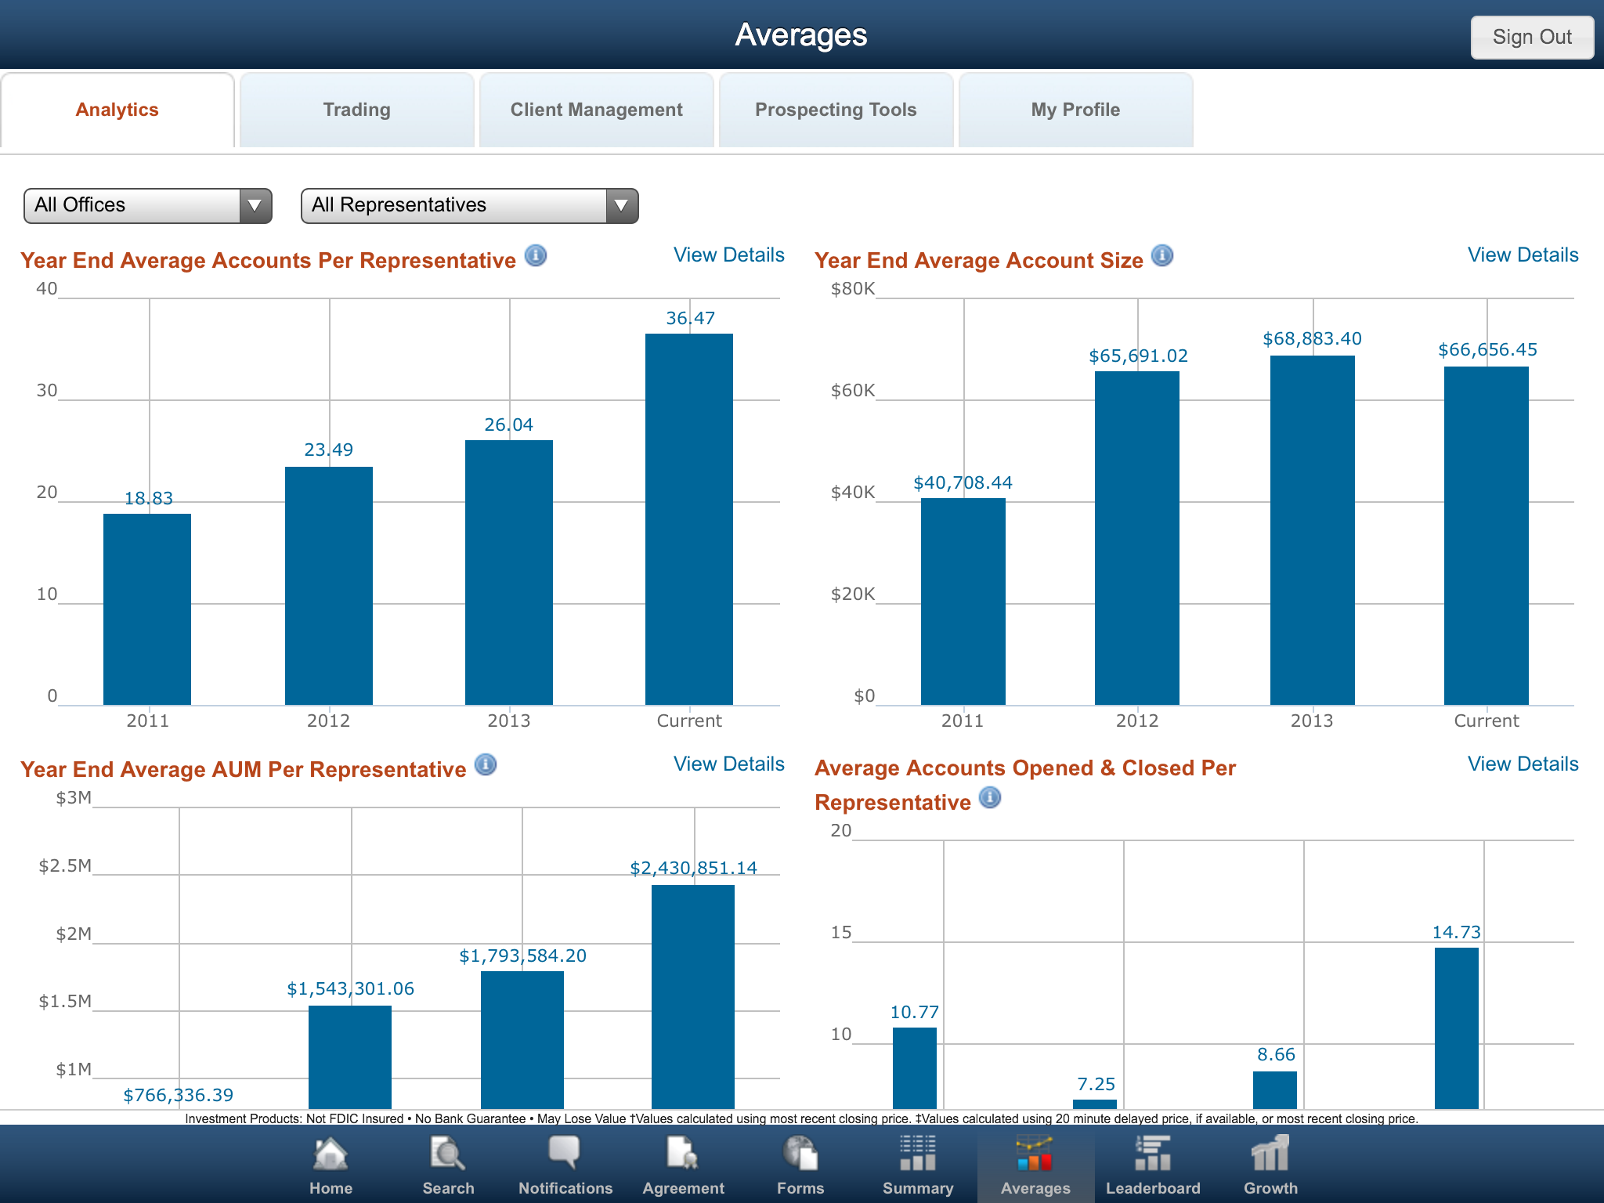

When viewing the Analytics tab on a tablet device, Averages, Leaderboard and Growth will appear as icons in the lower navigation bar. Tap the icons to view those pages. The icon will change from black and white to color to indicate the active page.

Optional Configuration – Aggregate Multiple Rep Records
This feature allows a RIA to aggregate analytics values for Representatives with multiple representative records on Liberty.
The functionality is available for Averages, Leaderboard and Growth sections.
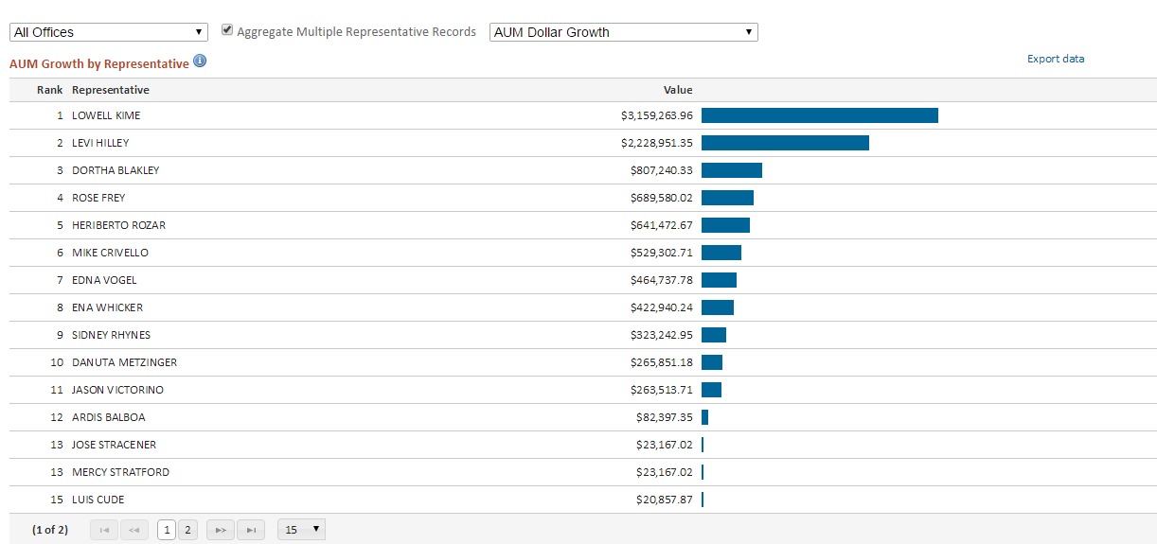
This checkbox control is visible to Investment Advisor user only, but the aggregate data will be visible to Representative users.
It is an optional feature and not enabled by default. Please contact your relationship manager should you require this feature.

Representative View
IA users will have the option to enable or disable Liberty Analytics for Representative users. As a default Liberty Analytics is disabled for Representative users. This feature can be enabled by contacting your relationship manager.

Averages
Representatives can view total, period end metrics for their own accounts. They will not have visibility into metrics for other offices or Representatives within the firm.
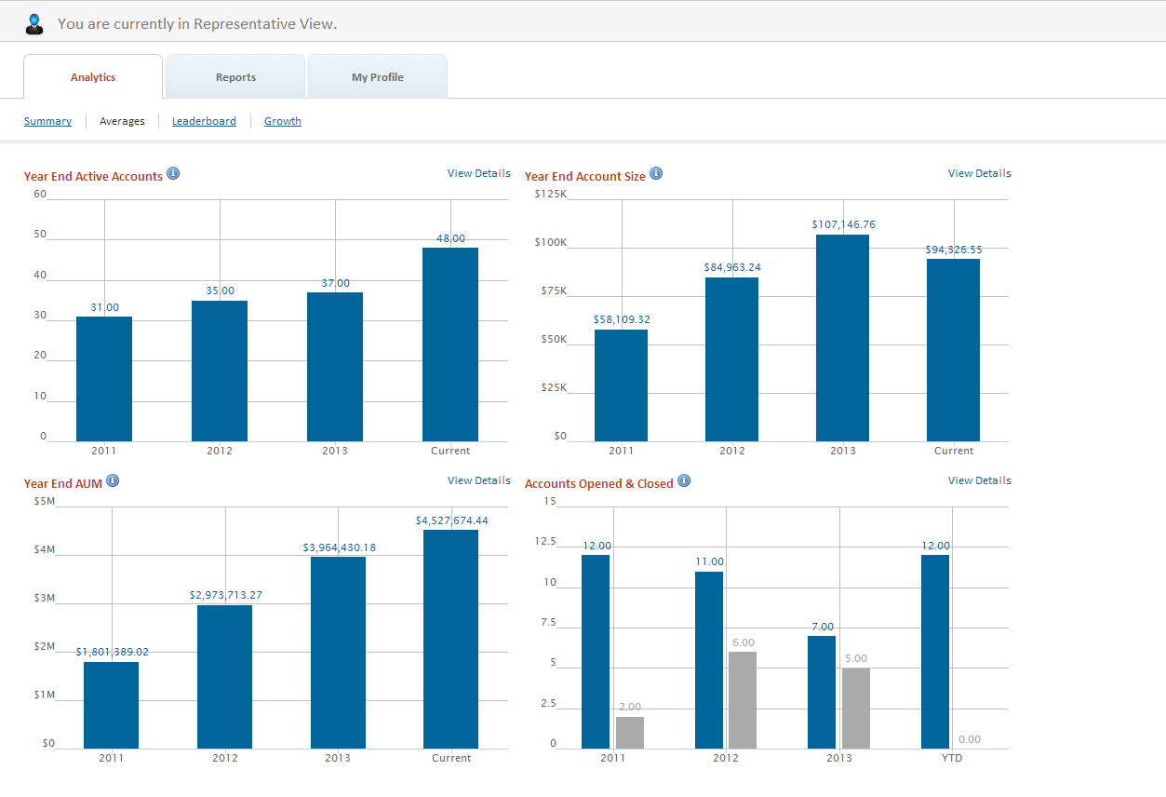

Leaderboard - Representative Name Display
IA users will have the option anonymize representative names within the leaderboard page within the Representative view.
As a default representative names will be visible to all users, but the RIA can choose to mask representative names for representative users. Representative users will see their own name, but not the names of other representative users.
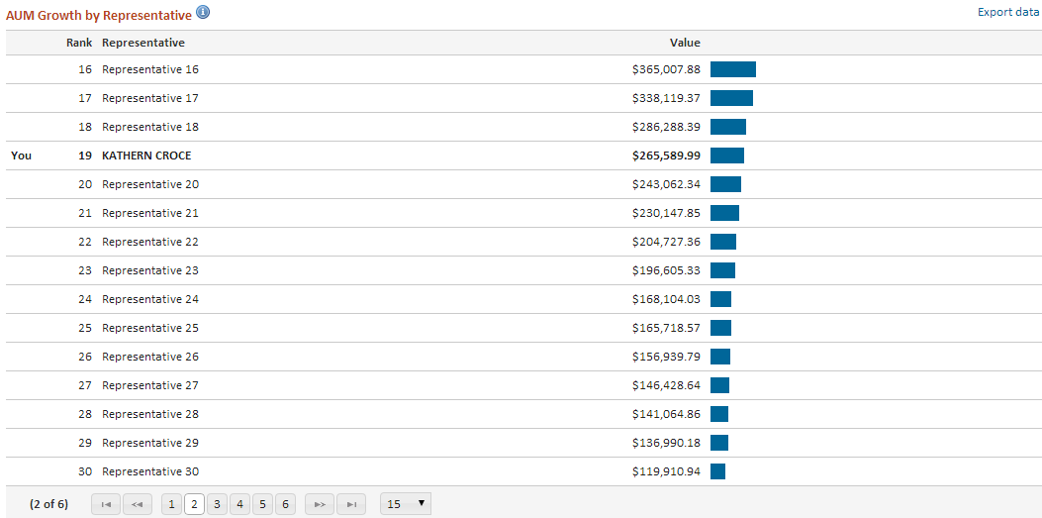

Growth
This section displays values for each month in the time period selected, and provides a view of performance over time. Growth metrics are available in both absolutes and percentage terms for the following items:
- AUM Growth Over Time
- Percentage AUM Growth Over Time
- Deposit Growth
- Withdrawal Growth

Representatives can view growth over time metrics for their own accounts. They will not have visibility into metrics for other offices or Representatives within the firm.
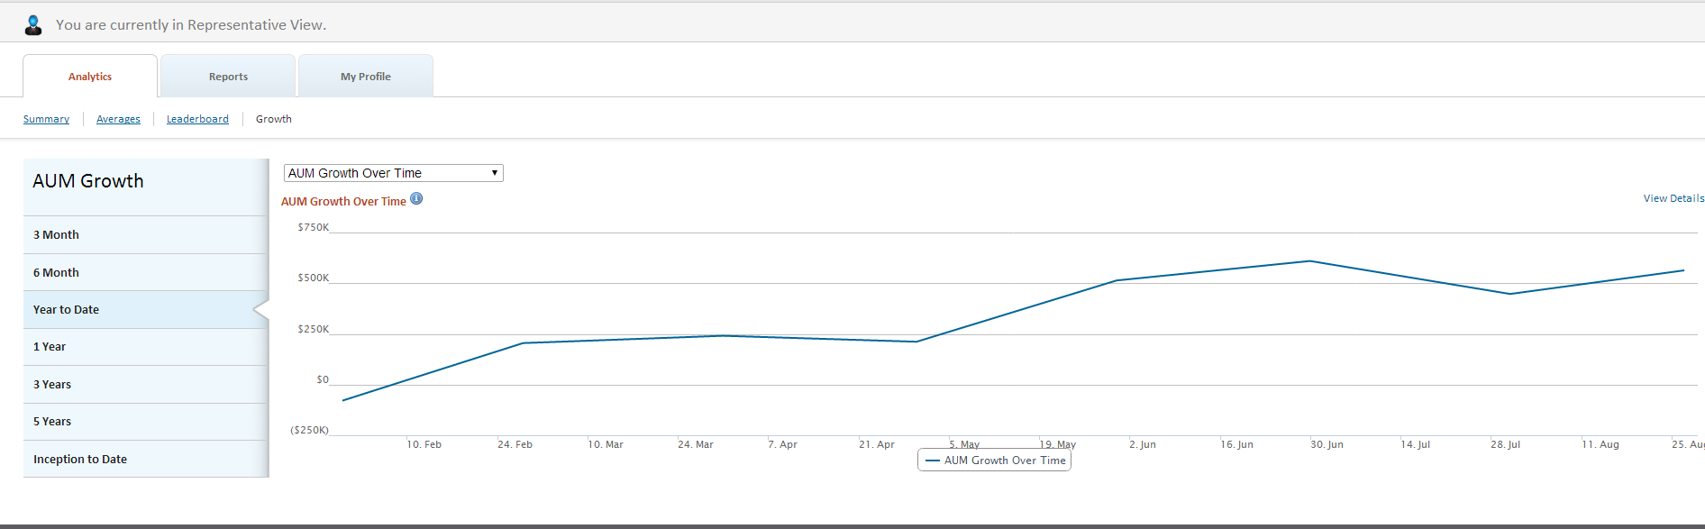

Business Rules

General
- Analytics data Incudes active, funded accounts only with no established term date.
- Representatives must have a minimum of one active account to be included in Analytics counts.
- Growth metrics are calculated only for representatives having data for the current period and at least one full prior period.
- Individual representative collations on the Averages page are totals rather than averages.

Account Changes
If an account is moved from one representative to another representative, the historic performance earned by the original representative will remain with that representative, although the current assets under management will be increased for the new representative and similarly decreased for the old representative.

This rule also applies at the Firm/Broker Dealer level, in the event that the new representative is associated with a different firm then the original representative. The system will not, however, count the event as an account closure under the old representative and account opening under the new representative.

Accounts with Multiple Representatives
On accounts with multiple representatives defined, the system will apportion deposits, withdrawals and market value based on the percent fee associated to each representative on the account. All representatives where the defined percent fee is greater than 0, however, will get credit for open accounts, closed accounts, etc. The system will automatically exclude special associated representatives that are only associated for the purpose of providing batch exports to other data services.

