January 2016

Liberty Trade Order Special Instructions
User Guide

Table of Contents
Quick Start Guide 3
Messages 3
Navigation 4
Edit Special Instructions 5
General Usage Notes 6

Quick Start Guide
Liberty now allows you to easily edit special instructions for multiple trade orders at once, saving you time and allowing you to trade more efficiently.
Edit Special Instructions is available in the Trading area of Liberty.
- From the Trading tab, click the Blotter link to display a list of all open trades.
- Select one or more eligible trades.
- Edit Special Instructions button in the action dock will be enabled.
- Edit Special Instructions screen will open, allowing you to change the parameters of the trade.
- Click Save to apply changes, or Cancel to discard changes.

Messages
There are several messages you will see as you perform actions within Liberty. In general, messages appear at the top of the screen with a colored background.
Informational messages appear with a blue background and an “I” icon. These messages typically confirm that you have successfully completed some action.
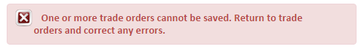
Critical messages appear with a red background and an ‘x’ icon. These messages indicate that something needs to be corrected before you can proceed.

Navigation
The Edit Special Instructions feature is located on the action dock of the Trade Blotter page. Once eligible trades are selected, the Edit Special Instructions button is enabled and the feature is ready for use.
The Trade Instruction (Buy Shares, Sell Shares) must be same for selected trades.
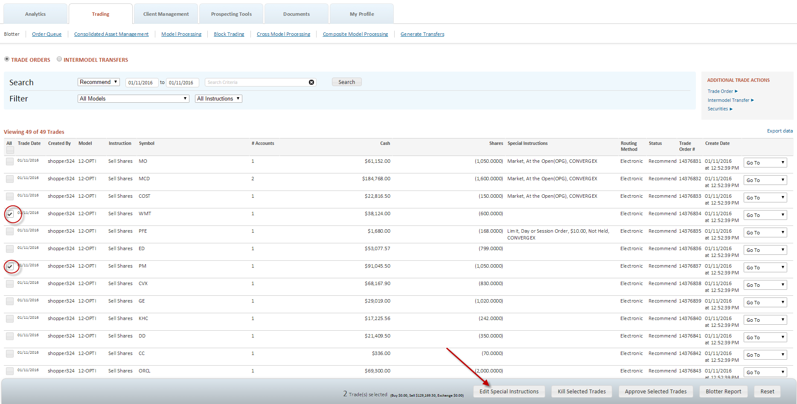
Once the trade orders are selected, a summary of the selection will display in the action dock.

Edit Special Instructions
The Special Instructions screen will display the instructions as defined originally in the trade order.
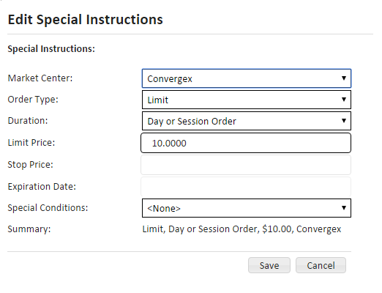
The following parameters can be edited:
Market Center: Convergex, Wallach Beth.
Order Type: Market, Limit, Stop, Stop Limit.
Duration: Day or Session Order, Good Till Cancel, At the Open, Good Till Date, At the Close
Limit Price: Enter limit price if Limit is selected in Order Type.
Stop Price: Enter Stop Price if Stop or Stop Limit is selected in Order Type.
Expiration Date: Enter expiration date only if Good Till Date is selected in the duration Option
Special Conditions: None, Not Held.

General Usage Notes
- Depending on the nature of a trade, some parameters may be disabled. Please contact your Relationship Manager for further information.
- If selected equities are different, Order Type will be disabled.
- This feature only applies to equity asset types.
- If selected equities are different, Order Type will be disabled.
- There is no upper limit to how many Special Instructions can be edited at the same time.
- Individual Trade Order Special instructions can also be edited within the trade order :
