Reduce liability and risk while delivering a higher fiduciary standard

Download now:

Trust Company of America (TCA) is now integrated with Fi360’s Fiduciary Focus Toolkit, which can provide you with a higher level of compliance with new fiduciary requirements as you manage client accounts.
Fi360 provides a powerful, web-based software solution that provides the analytical, management and reporting features needed to help advisors manage and document a prudent investment process. The turn-key fiduciary management system is easy to use, easy to replicate and easy to understand.
Fiduciary Focus Toolkit provides:
- Fiduciary Score analysis for comparing peer investments and determining appropriateness for client portfolios
- Built in tools to promote compliance as you manage your investment process, from proposals and IPS creation to watch-list management and client reports
- A robust Investment Analyzer that facilitates best-in-class investment searches as you map to a fiduciary due diligence process.
Through TCA’s partnership, advisors receive 15% off the cost of the Fiduciary Focus Toolkit software with an annual subscription.

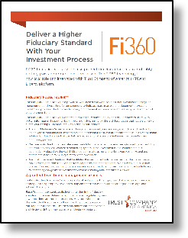

Join us for an informative webinar to learn more about Fi360:
When: October 25th
Time: 2:30 pm MT
Stay tuned for further details!
Register early here.

You may contact Fi360’s Business Development Team, with any questions about Fi360 at:
- (866) 390-5080 and sales@fi360.com.

