A text field has been added to the Trade Blotter on Liberty allowing you to narrow your search results.
You can enter at least one character and click Search to obtain results.
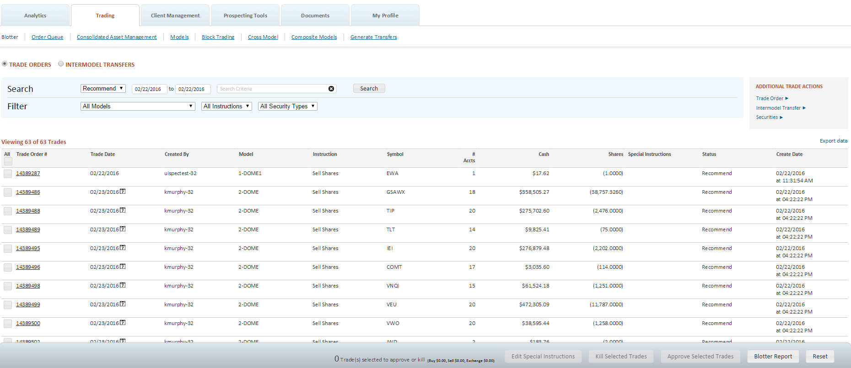

Let you relationship manager know if you have questions.

